Excursion:
Sweden – Helsinki – Saint Petersburg – Joensuu – Helsinki – Sweden
Peter Lohmander
Document under development
Version 2012-03-01

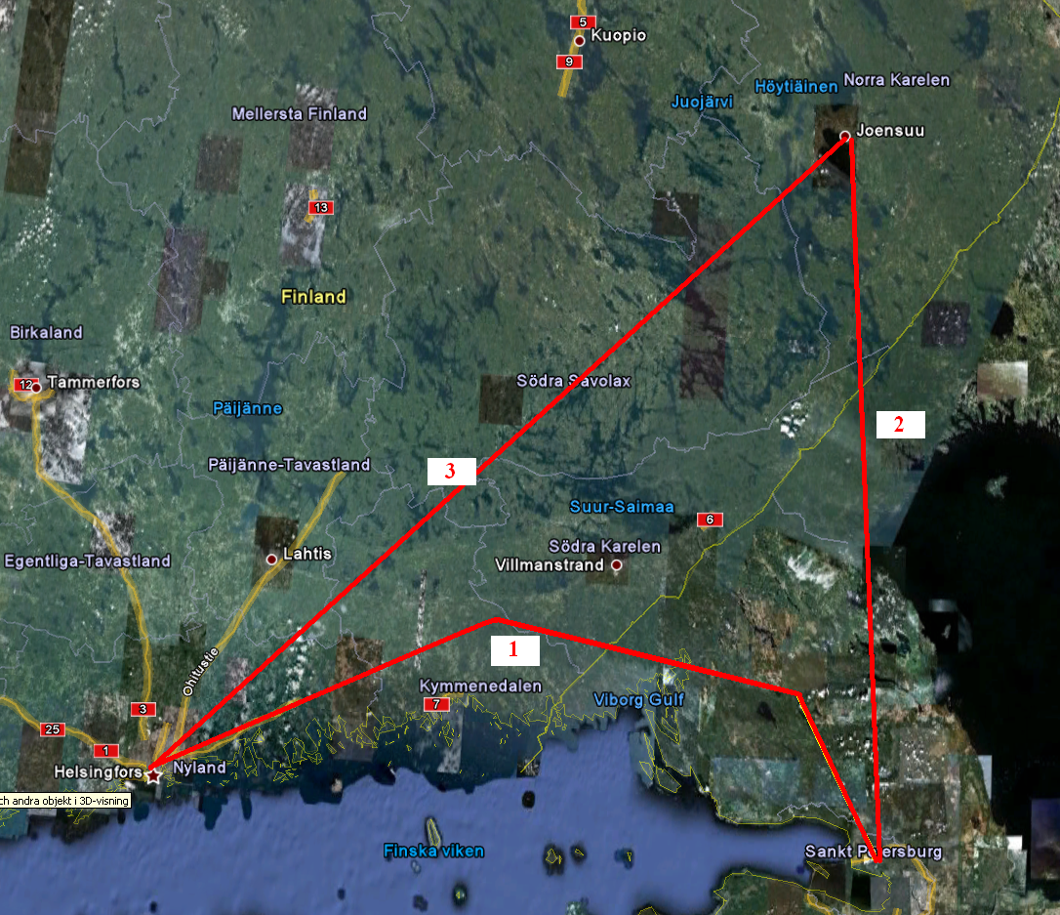

Figure 1.
Travel Summary Map.

Flight from Umea to Helsinki. Participants: 23 master of forestry students, Peter Lohmander and Marine Elbakidze, from Swedish University of Agricultural Sciences, SLU.
In Helsinki, we rent a bus. This bus will be used all the time until we come back to Helsinki again. Bus ride #1 (marked with a red “1” on the map) will be as rapid as possible. We have to reach Saint Petersburg according to schedule. We go by bus to Saint Petersburg and follow the excursion arranged by Maxim Chubinsky. Then, we go to Joensuu (Bus ride #2) where we visit EFI. The main coordinator in Finland is Maarit Kallio. It is good if we can make some field visits during Bus ride #2, in Russia and in Finland. In Joensuu we visit EFI and then go on Bus ride #3. We would also like to make field visits along ride #3. Then, we come to Helsinki, where we have the final part of the tour. Flight from Helsinki to Umea.

Excursion Plan

Date | Day | Time | Place | Activity | Coordinator
Apr 11 | Wednesday |  |  | Travel Umea – Saint Petersburg
 |  |  |  | Individual transport to Umea airport (Alvik)
 |  | 06.00 |  | The group meets at Umea airport (Alvik). Practical details and last minute information. Check in. | Peter L
 |  | 07.00-08.00 |  | Flight from Umea (Alvik) to Stockholm (Arlanda)  (Carrier: Norwegian) | Peter L
 |  |  |  | The group instantly gathers when we leave the plane. We walk together through the Arlanda airport to the international terminal. Continuous information about practical details and last minute information. We walk as a group, together.
 |  | 10.30 -12.25 |  | Flight from Stockholm (Arlanda) to Helsinki  (Carrier: Finnair) | Peter L
 |  |  |  | ADJUST YOUR WATCH!
 |  |  |  | The group instantly gathers when we leave the plane. We walk together through the Helsinki airport and collect our luggage. Continuous information about practical details and last minute information. We walk as a group, together, to the bus. | Peter L
 |  |  |  | Bus ride from Helsinki to Saint Petersburg.  Along the tour, we make stops to eat etc.. | Peter L
 |  |  | Saint Petersburg, Close to FTU | HOSTEL reserved by Maxim C which will be used until we leave Russia. Double rooms for all 23 students and two single rooms for Peter L and Marine E.  (2 > persons in room - 500 rubles for each, 1 person - 1200 rubles, breakfast not included, but it possible to buy breakfast+dinner - 150-250 rubles. Bathrooms and showers in the floor. Linen included.)  One more single room for the bus driver. | Maxim C
 |  |  |  | ADJUST YOUR WATCH!
Apr 12 | Thursday |  |  | Excursion RUSSIA  http://en.wikipedia.org/wiki/Saint-Petersburg  http://www.dodekanissaweb.gr/world/cities/Saint-Petersburg-Russia.html  http://maps.thefullwiki.org/Saint_Petersburg  http://www.forest.ru/eng/publications/intact/ | Maxim C
 |  | 09.00- 12.00 |  | A1 Forestry in Russia. Forest Technical University.  FTU (Earlier name: SPbFTA):  General information about FTU. Maxim Chubinsky  Dr., Executive Director of ICFFI, Vice-Dean of Forest Faculty, FTU  http://ftacademy.ru/eng/academy.html  Forestry in Russia. Evgeny Kuznetsov  Ass. Prof., Forestry Department, FTU  http://ftacademy.ru/eng/academy.html  Forests and forest resources of Russia and their use, by Alexander Alekseev (page 20) | Maxim C
 |  | 12.00 13.00 |  | A2 Lunch | Maxim C
 |  | 13.00- 16.00 |  | A3 Botanical garden and museums of FTU | Maxim C
Apr 13 | Friday |  |  | Excursion RUSSIA | Maxim C
 |  | 09.00- 11.00 |  | B1 Forest market in Russia  Forest Market in Russia. Anatoly Chubinsky  Professor, Forest Economics  Faculty and Mechanical Technology of Wood Faculty, FTU  http://www.springerlink.com/content/w550525420m06285/fulltext.pdf  Report from the IFC and the World Bank | Maxim C
 |  | 11.00– 12.00 |  | B2 Lunch | Maxim C
 |  | 12.00-16.00 |  | B3 Forest Policy in Russia  The Forest law: Forest Codex.  Alexey Jaroshenko, Leader of forest department Greenpease Russia.  http://www.greenpeace.org/russia/en/  Forest policy in Russia.  Nikolay Shmatkov, Leader of Forest Policy Department, WWF in Russia  http://www.wwf.ru/eng/  Forest monitoring in Russia.  Roman Glebov, Leader of North-West Russia Forest Monitoring Center.  http://www.scanex.ru/en/publications/pdf/publication23.pdf  Forest inventory in Russia.  Someone from Federal Forest Inventory Organization.  http://www.globalforestwatch.org/english/russia/news.htm  Problems in forestry in Russia.  Someone from Rosleshoz.  http://www.rosleshoz.gov.ru/english  Topics not desided yet.  Someone from Swedwood and/or Stora Enso.  http://www.axelspringer.de/dl/344752/tracing_wood_imports_klein.pdf  http://www.metla.fi/dissertationes/df95.pdf  http://www.globalforestwatch.org/english/russia/gfw.htm  http://www.taigarescue.org/index.php?sub=2&cat=65 | Maxim C
Apr 14 | Saturday |  |  | Excursion RUSSIA | Maxim C
 |  | 09.00 - 16.00 |  | C1 Lindulovskaja forest  http://www.baltic.pu.ru/forecast.eng/karelia/karelia.htm  LINDULOVSKAYA ROSHCHA  Lindulovkaya forest | Maxim C
Apr 15 | Sunday |  |  | Bus from Saint Petersburg to Joensuu.  From Dr Olga Tyukina:  “The topic during our bustrip from St. Petersburg to Vyborg will be Logging in Russia: economic, management and organization. The basic  document will be my Ph.D. thesis http://www.metla.fi/dissertationes/df106.htm (2010). In addition to the website, I send you attached the text I will talk about in the bus. Also, I will show some books and talk about the key directions in the economic of Russian logging activity.” (The text is included in the end of this document.)  Dr. Olga Tyukina defended her PhD thesis at School of Forest Science, Faculty of Science and Forestry,  University of Eastern Finland.
 |  |  |  | ADJUST YOUR WATCH!
RESERVATIONS in process via CarlsonWagonlit:
HOSTEL two nights in Joensuu. Check in April 15 and check out April 17.
7 double rooms for 14 male students,
4 double rooms and one single room for 9 female students, three single rooms for Peter L., Marine E. and the bus driver.
If possible: We want breakfast.
We want bathrooms and showers.

Apr 16 | Monday |  |  | Excursion FINLAND | Maarit K
 |  | 09:00-10:00 | Siltakatu 20B, Joensuu  tel. +358 20 772 8200  (växel)  tel. +358 20 7728203  (Niskanen) | D1 The Finnish Forestry Centre - North Karelian Unit  Dr. Anssi Niskanen, Director.  -Role of forest centers in implementing the Finnish forest policy  -Actual national and local forest policy issues  http://www.metsakeskus.fi/briefly-in-english  http://www.skogscentralen.fi/metsakeskus-ja-alueet  http://www.skogscentralen.fi/pohjois-karjala | Maarit K
 |  | 10:00-10:15 |  | D2 Moving to Metla house; | Maarit K
 | 30 min | 10:15-  10:45 | Metla  Yliopistokatu 6, Joensuu,  Auditorimum Käpy | D3 Metla, Joensuu  Wellcome and presentation of the wooden Metla building  Dr. Jari Miina, Metla (tel. +358 503913106)  http://www.metla.fi/tiedotteet/2004/2004-11-10-metla-house-photos.htm  http://www.metla.fi/jo/index-en.htm | Maarit K  JM said this takes 20–30 min.
 | 45 min | 10:45-  11:30 | Metla  Yliopistokatu 6, Joensuu,  Auditorimum Käpy | D4 Wood Construction in Finland: future prospects and opportunities  Mr. Harri Välimäki, Development Manager/ or / Mr. Jukka Lempiäinen/ Joensuu Science Park, OSKE. Länsikatu 15, puh. +358 50 379 9112, http://www.carelian.fi/en/front+page/ | Maarit K
 | 45 min | 11:30  -12:15 | Restaurant Metla  Yliopistokatu 6, Joensuu | D5 A lunch break, personnel restaurant at Metla house (lunch at own cost, 6–7 €/person) | Maarit K
 | 45 min | 12:15 -13:00 | Metla  Yliopistokatu 6, Joensuu, Käpy | D6 Dr. Tarmo Räty, Sen.res., Metla: Environmental performance of construction wood, environmental certificates and standards | 14:00-15:30
 | 90 min | 13.00 – 14.30 | EFI, at Metla’s Auditorimum Käpy  EFI is currently split into several places due to air problems (mould) in Torikatu 4. None of the temporary locations hosts 25 visitors. So, EFI proposed to presents its work at Metla’s premises. | D7 European Forest Institute,  Contact person: Maria Jalavisto (tel. +358 10 773 4337)  - Introduction to EFI  - EFI research on International forest policies  Note: 16.4. is a day for EFI’s board meeting. All directors and some of the senior researchers and other staff members are in Vienna for this meeting. | Maarit K
 |  | 14:30-15:00 | Metla  Yliopistokatu 6 | D8 Coffee Break (on Metla’s account) | Maarit K
 |  | 15–16 | Metla  Yliopistokatu 6, Joensuu,  Auditorimum Käpy | D9 Open. Possible topic:  Wood based bioenergy in Finland; Current role and future goals; procurement / N.N.
Apr 17 | Tuesday |  |  | Excursion FINLAND | Maarit K
 |  | 08.30 – 11.30-12:45 | Bus: Joensuu-Vilmannstrand (235 km ~ 3 hours) | E1 Bus heading South.  -Arrival in the Kaukas mill area;  -Lunch break before mill visit in either one of the personnel restaurant (kept by Amica), at own cost.  -Moving to the first excursion location (mill area is rather large; moving between pulp mill and biopower plant with own bus). | Maarit K
 |  | 12:45-xx:00 | UPM Kaukas  Villmanstrand  Tel.  +358 204 15 161  Kaukaan Voima Ab,  Villmanstrand  (Lappeenranta in Finnish) | E2 Visiting UPM Kymmene Kaukas pulp mill and Kaukaan voima Biopower plant  - Kaukas pulp and paper mill (pulp mill visited; paper mill may be temporarily shut down)  http://www.upm.com/en/Pages/default.aspx  http://w3.upm-kymmene.com/upm/internet/cms/upmcms.nsf/$all/  0EEDCF087560E843C2256D94003E320F?Open&qm=menu,0,0,0  http://www.upm.com/EN/ABOUT-UPM/Downloads/Responsibility/Documents/EnvironmentalStatements2010/envstat_kau_2010_en.pdf  - Kaukaan Voima Ab, biopowerplant  http://www.energy-enviro.fi/index.php?PAGE=715&PRINT=yes  (hope: discussion on fuels, costs, subsidies, regulations, district heating …)  Contact at Kaukas: Communications manager Mariitta Stenbäck. 0204 15 4465 | Maarit K  to be asked (MK):  -driving instructions in the mill area and in LPR to find the mill area  The exact timing (length) and order of the visit (pulp mill/ bioenergy first) confirmed by Kaukas later on.  Visit to:  Kaukas mill museum  -interest in Slu ?  -available?
 |  | xx-00 yy.00 | Villmanstrand-Helsingfors (220 km ~ 3 hours) | E3 Bus continuing towards Helsingfors  Depending on the time needed in Kaukas, possibly some sights on the road. | Maarit K
RESERVATIONS in process via CarlsonWagonlit:
HOSTEL one night in Vanda (Vantta), abut 10
km North of Helsinki, close to the points described below. Check in April 17 and check out April 18.
7 double rooms for 14 male students,
4 double rooms and one single room for 9 female students,
three single rooms for Peter L., Marine E. and the bus driver.
If possible: We want breakfast.
We want bathrooms and showers.
Apr 18 | Wednesday |  |  | Excursion FINLAND | Maarit K
 |  | 09.00 – 10:00 | Metsähallitus Vernissakatu 4, Dickursby, Vanda  +358 20564100 | F1 Metsähallitus/Forststyrelsen.  Dr. Antti Otsamo, Environment Manager, topic: Coordinating the use of the state forest lands for  their many demands  Links on Metsähallitus:  Swedish:  http://metsa.fi/sivustot/metsa/sv/Koncernen/Sivut/Koncernen.aspx  English:  http://metsa.fi/sivustot/metsa/en/AboutUs/Sivut/AboutMetsahallitus.aspx | Maarit K
 |  | 10:00-10:20 | Metsähallitus  - Metla | Moving on: walking from Metsähallitus to Metla, Vanda. 0.9 km.
 |  | 10.30 – 12:30 | Metla,  Jokiniemenkuja 1, Vanda  Auditorium | F2 Finnish biodiversity protection policies. Speakers with preliminary presentation titles.  - Ms. Terhi Koskinen, Metla, sen. res., METSO follow up group; Introduction to METSO programme and experiences from it;  - Ms. Maarit Loiskekoski, Senior Environment Adviser, Ministry of Agriculture and Forestry, METSO from the Ministry’s point of view.  - Dr. Riitta Hänninen, Metla, programme leader, Safeguarding forest biodiversity - results from the TUK research programme. http://www.metla.fi/pp/RHan/index-en.htm  Related links:  METSO 2008–2016 programme:  http://www.metsonpolku.fi/metso/www/sv/index.php  In Swedish  http://www.mmm.fi/sv/index/amnesomraden/skogar/metso.html  In English  http://www.mmm.fi/en/index/frontpage/forests/  sustainable_forest_management/forest_biodiversity.html  Monitoring METSO 2008–2016 programme at METLA:  http://www.metla.fi/hanke/3522/index-en.htm  TUK research programme at METLA:  http://www.metla.fi/ohjelma/tuk/index-en.htm | Maarit K
 |  | 12:30-13:15 | Rosmariini, Metla  Jokiniemenkuja 1 | F3 Lunch at Metla staff restaurant Rosmariini  (at own cost, 6.8 €/person) | Maarit K
 |  | 13:15-14:00 | Metla,  Jokiniemenkuja 1, Auditorium | F4 Finnish forests and climate change  (possible speakers could be Tarja Tuomainen or Aleksi Lehtonen, Metla; to be confirmed; http://www.metla.fi/hanke/3431/index-en.htm);  - Greenhouse gas reporting for the Kyoto protocol in the Finnish LULUCF sector  - Finnish forest in climate change mitigation after Durban | Maarit K
 |  | 14:00-14.15 |  | Coffee break | Maarit K
 |  | 14.15–15.15 | Metla,  Jokiniemenkuja 1, Auditorium | F5 Dr. Tatu Torniainen, Ministry of Agriculture and Forestry, Topical Issues in the Finnish Forest Policy | Maarit K
 |  | 15:15-16:00 | Auditorium  Metla, Ånäsgränden 1 (Jokiniemenkuja 1) | F6 Dr. Hanna-Liisa Kangas, WWF Finland,  WWF’s views on forests and climate change.  http://www.wwf.fi/wwf/www/uploads/pdf/WWF_Hugga_eller_skydda_Boreala_skogar_i_klimatperspektiv.pdf | Maarit K
 |  | 16:10 |  | Bus to the Helsinki airport
 |  |  |  | The group meets at the Helsinki airport. Practical details and last minute information. Check in.
 |  |  |  | Hopefully: Some time to eat at the airport.
 |  | 18.55– 18.50 |  | Flight Helsinki to Stockholm (Arlanda)  (Carrier: Norwegian) | Peter L
 |  |  |  | ADJUST YOUR WATCH!
 |  |  |  | The group instantly gathers when we leave the plane. We walk together through the Arlanda airport and collect our luggage. (We probably have to collect our luggage and carry it through the customs and check it in again before we go to Umea.) Continuous information about practical details and last minute information. We walk as a group, together, to the next flight.
 |  | 20.20 -21.20 |  | Flight Stockholm (Arlanda) to Umea (Alvik)  (Carrier: Norwegian) | Peter L
 |  |  |  | Individual transport from Umea (Alvik) airport

Contacts

Maxim Chubinsky
Dr., Executive Director of ICFFI, Vice-dean of Forest Faculty,
Saint Petersburg Forest Technical Academy,
Institutsky per. 5, St. Petersburg,
Russia 194021
e-mail: mchubinsky@gmail.com
Phone 1: +7 911 026 10 24,
Phone 2 : +7 812 670 93 90

Marine Elbakidze
Associate Professor
SLU, School for Forest Engineers
PO Box 43
S-739 21 SKINNSKATTEBERG
SWEDEN
e-mail: Marine.Elbakidze@slu.se
Phone: +46 222 349 50
Maarit Kallio
D.Sc.
The Finnish Forest Research Institute
PL 18, FI-01301 VANTAA, FINLAND
E-mail: maarit.kallio@metla.fi
Phone: +358 10 211 5434
Mobile phone: +358 40 801 5434

Peter Lohmander
Professor Dr.
SLU, Faculty of Forest Sciences, Dept. of Forest Economics,
SE-901 83 Umea, Sweden
e-mail 1: Peter@Lohmander.com
e-mail 2: Peter.Lohmander@SLU.se
Phone: +46-70-6925210

Camilla Widmark
PhD, Assistant Professor in Forest Policy
Department of Forest Economics
Swedish University of Agricultural Sciences
SE-901 83 Umea, Sweden
e-mail: camilla.widmark@slu.se
Phone: +46 90 786 85 96

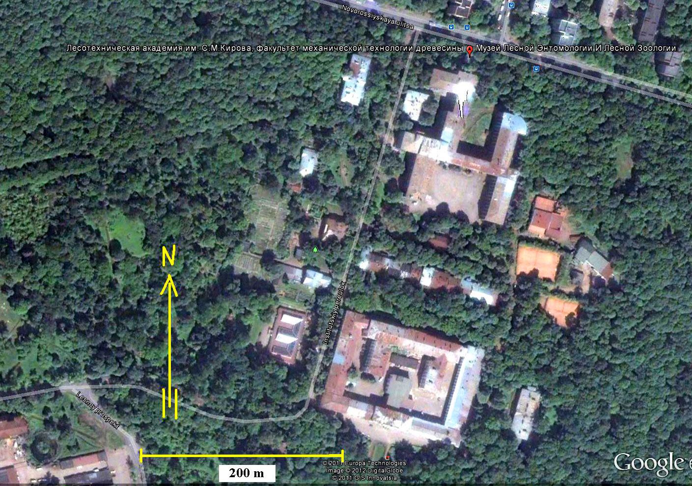

Figure 2.
FTU (Earlier name: SPbFTA, Saint Petersburg Forest Technical Academy), Map by Peter Lohmander, 120112.

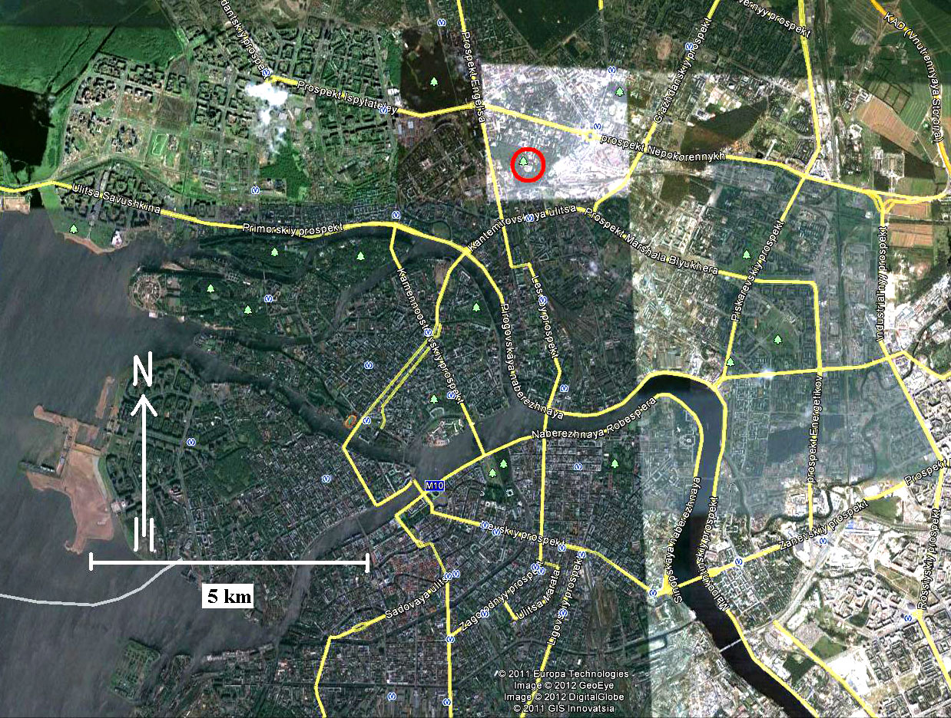

Figure 3.
FTU (Earlier name: SPbFTA, Saint Petersburg Forest Technical Academy), is marked by a red circle in t his map of Saint Petersburg. Map by Peter Lohmander, 120112

Some earlier international forest policy excursions

Below, you can look at plans and pictures from similar International Forest Policy excursions:

Russia-Estonia 2007:
Plan:
http://www.lohmander.com/IFP.doc

Spain-Andorra-France 2008:
Plan:
http://www.lohmander.com/IFP08/IFP08.html

Pictures:
http://www.lohmander.com/SAF08/SAF08.htm

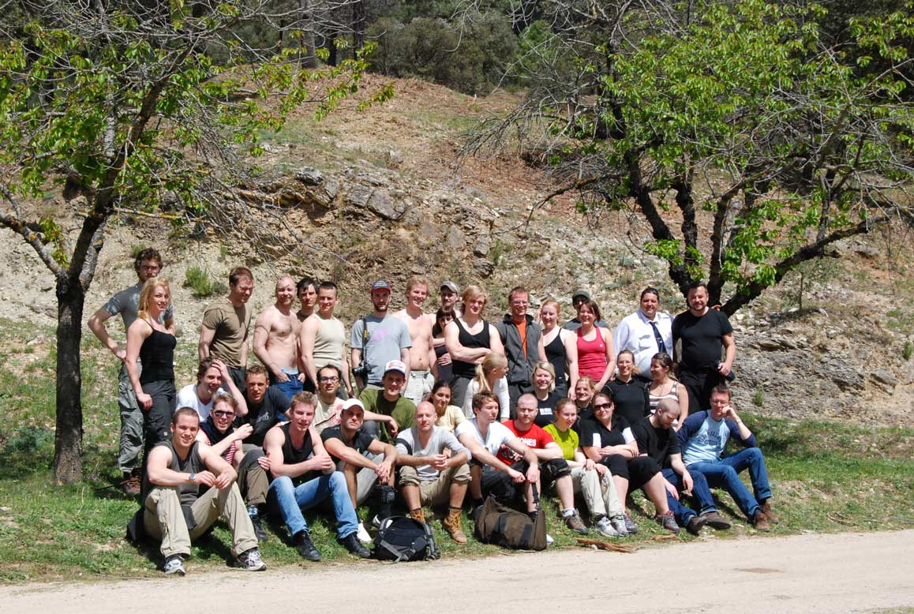
Above: The forest policy excursion to Spain-Andorra-France 2008

Switzerland-Germany 2009:
Plan:
http://www.lohmander.com/IFP09/IFP09.htm

Pictures:
Switzerland:
http://www.lohmander.com/Swiss09/Swiss09.htm

Germany:
http://www.lohmander.com/Germ09/Germ09.htm

International Forest Policy lectures by Peter Lohmander 2012

Forest policy and consequences for activities in the forest industry sector,
regional employment, economic results and international trade
(Skogspolitik och dess konsekvenser för skogsindustrisektorns verksamhet,
regional sysselsättning, ekonomiska resultat samt internationell handel)

References to the lectures:

Lohmander, P., Trade and Imperfections 2009 ppt
http://www.lohmander.com/IFP09/Trade%20and%20Imperfections%202009.ppt

Lohmander, P., Lägg inte ned Svensk skogsindustri på grund av virkesbrist, Krönika, Nordisk Papper och Massa 8/2007
http://www.Lohmander.com/kronika_NPM07.pdf

Lohmander, P., Ekonomiskt rationell utveckling för skogs- och energisektorn i
Sverige, Nordisk Papper och Massa, Nr 3, 2008

Lohmander, P., Ekonomiskt rationell utveckling för skogs- och energisektorn,
Nordisk Energi, Nr. 4, 2008

Lohmander, P., Strategic options for the forest sector in Russia
with focus on economic optimization, energy and sustainability
http://www.Lohmander.com/RuMa09/RuMa09.htm

Lohmander, P., Strategiska möjligheter för skogssektorn i Ryssland
Nordisk Papper och Massa, Nr 2, 2009
http://www.Lohmander.com/PL_NPM_2_2009.pdf
http://www.Lohmander.com/PL_RuSwe_09.pdf
http://www.Lohmander.com/PL_RuSwe_09.doc

Lohmander, P., Derivation of the economically optimal joint strategy for
development of the bioenergy and forest products industry,
CD, MarcusEvans, 2nd Annual European Biomass and Bioenergy Forum,
London, 8th - 9th June 2009
http://www.lohmander.com/London09/London_Lohmander_09.ppt
http://www.lohmander.com/London09.pdf

Lohmander, P., KEYNOTE: Economic optimization of sustainable energy systems based on forest resources with consideration of the global warming problem: International perspectives,
SSAFR-2001, 14th Symposium for Systems Analysis
in Forestry, Abstracts, Maitencillo, Chile, March 8-11, 2011,
http://www.lohmander.com/Chile_2011/Chile_2011_Keynote_Lohmander.ppt

Lohmander, P., Ekonomisk skogsproduktion m.h.t. skogsindustri och energiindustri, Economic forest production with consideration of the forest and energy industries, June 7, 2011
http://www.lohmander.com/PL_EON_110607.pdf

Segerstedt, R., (Interview with Peter Lohmander), Därför har professorn hamnat i kylan, Skogsland Nr 6, 3 February, 2012
http://www.Lohmander.com/PLSkogsland120203.pdf

Forest policy with focus on:
- Rational development of the forest sector with consideration of energy, CO2 emissions, wildlife, recreation, Russia, world trade, continuous cover forestry and round wood market imperfections

Segerstedt, R., (Interview with Peter Lohmander), Därför har professorn hamnat i kylan, Skogsland Nr 6, 3 February, 2012
http://www.Lohmander.com/PLSkogsland120203.pdf

Lohmander, P., Ekonomisk skogsproduktion m.h.t. skogsindustri och energiindustri,
Economic forest production with consideration of the forest and energy industries,
June 7, 2011
http://www.lohmander.com/PL_EON_110607.pdf

Lohmander, P., Economic forest management with consideration
of the forest and energy industries,
BIT’s 1st World Congress on Bioenergy, Dalian World Expo Center,
Dalian, China, April 25-30, 2011
http://www.lohmander.com/PRChina11/WorldCongress11_PL.pdf
http://www.lohmander.com/ChinaPic11/LohmanderTalk.ppt

Lohmander, P., Optimal ekonomisk skogs och energipolicy,
Energiutblick 2011, Energimyndigheten,
Bioenergi för småskalig kraftvärme, Mars 2011,
http://www.lohmander.com/Energiutblick_2011_Lohmander.ppt

Lohmander, P., Optimization of the forest and bioenergy supply
chain in Sweden,
SSAFR-2001, 14th Symposium for Systems Analysis in Forestry,
Maitencillo, Chile, March 8-11, 2011,
http://www.lohmander.com/Chile_2011/Chile_2011_Chain_Lohmander.ppt

Lohmander, P., Spatial dynamic optimization of district heating
and/or cooling systems based on forest resources,
SSAFR-2001, 14th Symposium for Systems Analysis in Forestry,
Abstracts, Maitencillo, Chile, March 8-11, 2011,
http://www.lohmander.com/Chile_2011/Chile_2011_Spatial_Lohmander.ppt

Lohmander, P., KEYNOTE: Economic optimization of sustainable energy systems
based on forest resources with consideration of the global warming problem:
International perspectives, SSAFR-2001, 14th Symposium for Systems Analysis
in Forestry, Abstracts, Maitencillo, Chile, March 8-11, 2011,
http://www.sistemasdeingenieria.cl/seminarios/index.php?id_seminario=22&idioma=en&pagina=participantes
http://www.lohmander.com/Chile_2011/Chile_2011_Keynote_Lohmander.ppt

Lohmander, P., Hur många älgar har vi råd med?, Vi Skogsägare, Debatt, Nr 1, 2011,
http://www.lohmander.com/Lohmander_Vi_Skogsagare_1_2011.pdf

Lohmander, P., Älgarnas Kostnads- Intäktsanalys,
(Background and manuscripts with different degrees of detail to an article)
http://www.lohmander.com/Jakt10/AlgmanusFinal.doc
http://www.lohmander.com/Jakt10/Algartikel101129.pdf
http://www.lohmander.com/Jakt10/Algartikel101129.doc
http://www.lohmander.com/Jakt10/Algkalkyl.xls

Lohmander, P., Zazykina, L., Methodology for optimization of continuous cover
forestry with consideration of recreation and the forest and energy industries,
Report and Abstract, Forests of Eurasia, Publishing House of
Moscow State Forest University, September 19 - 25, 2010
http://www.lohmander.com/Moscow10/Moscow10_PL_LZ.pdf
http://www.lohmander.com/Moscow10/Moscow10_PL_LZ.doc
http://www.lohmander.com/Moscow_PL_2010.pdf
http://www.lohmander.com/Moscow_2010/Lohmander_Zazykina_Moscow_2010.ppt
http://www.lohmander.com/Moscow_2010/Programma-LE_10_01.doc

Lohmander, P., Methodology for optimization of coordinated forestry,
bioenergy and infrastructure investments with focus on Russian Federation,
Plenary Report and Abstract, Forests of Eurasia, Publishing House of
Moscow State Forest University, September 19 - 25, 2010
http://www.lohmander.com/Moscow10/Moscow10_PL.pdf
http://www.lohmander.com/Moscow10/Moscow10_PL.doc
http://www.lohmander.com/Moscow_PL_2010.pdf
http://www.lohmander.com/Moscow_2010/Lohmander_Moscow_2010.ppt
http://www.lohmander.com/Moscow_2010/Programma-LE_10_01.doc

Lohmander, P., Optimum combination of biomass
production with investments in infrastructure,
CD, MarcusEvans, 3rd Annual European Biomass and Bioenergy Forum,
Stockholm, 13th - 15th September 2010
http://www.lohmander.com/EBBF_2010_Lohmander.ppt
http://www.lohmander.com/EBB_2010.pdf

Lohmander, P., DHINV, Program for dynamic optimization of
district heating and cooling systems investments in a region, Appendix 4 in:
Lacruz, R.F., Economically optimal coordinated expansion of district heating,
CHP and bioenergy in a region, SLU, Umea, Dept. of Forest Economics, September, 2010
http://www.Lohmander.com/Lacruz_sept_2010.pdf

Lohmander, P., Zazykina, L., Rational and sustainable utilization of forest
resources with consideration of recreation and tourism, bioenergy,
the global warming problem, paper pulp and timber production: A mathematical approach,
Proceedings of the II international workshop on Ecological tourism,
Trends and perspectives on development in the global world,
Saint Petersburg Forest Technical Academy, April 15-16, 2010
http://www.Lohmander.com/SPb201004/Lohmander_Zazykina_SPbFTA_2010.pdf
http://www.Lohmander.com/SPb201004/Lohmander_Zazykina_SPbFTA_2010.doc
http://www.Lohmander.com/SPb201004/PPT_Lohmander_Zazykina_SPbFTA_2010.ppt
http://www.Lohmander.com/SPb201004/PPT_Lohmander_Zazykina_SPbFTA_2010.pdf

Kjellin, P., (Interview with Peter Lohmander), Sveaskogs inträde som virkesköpare på marknaden är inget problem, det förbättrar snarare konkurrensen, Skogsland Nr 52/53 2009
http://www.Lohmander.com/Lohmander_Skogsland_091218.pdf

Flyckt, R. (Interview with Peter Lohmander concerning continuous cover forestry, p.4-5), Naturkultur - frälsning eller villolära, Skogseko Nr. 3, 2009
http://www.skogsstyrelsen.se/episerver4/templates/SNormalPage.aspx?id=43015#
http://www.Lohmander.com/Skogseko_3_2009.pdf

Lohmander, P., Strategiska möjligheter för skogssektorn i Ryssland
Nordisk Papper och Massa, Nr 2, 2009
http://www.Lohmander.com/PL_NPM_2_2009.pdf
http://www.Lohmander.com/PL_RuSwe_09.pdf
http://www.Lohmander.com/PL_RuSwe_09.doc

Lohmander, P., Stor potential för svensk skogsenergi, Nordisk Energi, Nr. 2, 2009
http://www.Lohmander.com/Information/ne1.jpg
http://www.Lohmander.com/Information/ne2.jpg
http://www.Lohmander.com/Information/ne3.jpg
http://www.Lohmander.com/PL_SvSE_090205.pdf
http://www.Lohmander.com/PL_SvSE_090205.doc

Lohmander, P., Satsa på biobränsle, Skogsvärden, Nr 1, 2009
http://www.Lohmander.com/PL_SV_1_09.jpg

Lohmander, P., Strategic options for the forest sector in Russia with focus on economic optimization, energy and sustainability
(Full paper in English with short translation to Russian), ICFFI News, Vol. 1, Number 10, March 2009
http://www.Lohmander.com/RuMa09/RuMa09.htm

Lohmander, P., Skogsägaren måste ändå bestämma, Västerbottenskuriren, Repliken, 2009-03-25, http://www.Lohmander.com/Lohmander_VK_090325.pdf
http://www.Lohmander.com/Lohmander_VK_090325.doc
http://www.vk.se/Article.jsp?article=264258

Lohmander, P., Öka avverkningen och hjälp Sverige ur krisen, VI SKOGSÄGARE, Debatt, Nr. 1, 2009 http://www.lohmander.com/PLdebattVIS2009nr1.pdf

Lohmander, P., Optimal dynamic control of the forest resource with changing energy demand functions and valuation of CO2 storage, UE2008.fr, The European Forest-based Sector: Bio-Responses to Address New Climate and Energy Challenges? Nancy, France, November 6-8, 2008 http://www.lohmander.com/Nancy08/Nancy08.ppt

Lohmander, P., Optimal CCS, Carbon Capture and Storage, Under Risk, International Seminars in Life Sciences, Universidad Politécnica de Valencia, Thursday 2008-10-16 http://www.lohmander.com/OptCCS/OptCCS.ppt

Lohmander, P., Tools for optimal coordination of CCS, power industry capacity expansion and bio energy raw material production and harvesting, 2nd Annual EMISSIONS REDUCTION FORUM: - Establishing Effective CO2, NOx, SOx Mitigation Strategies for the Power Industry, CD, Marcus Evans Ltd, Madrid, Spain, 29th & 30th September 2008 http://www.lohmander.com/Madrid08/Madrid_2008_Lohmander.ppt

Lohmander, P., Optimal resource control model & General continuous time optimal control model of a forest resource, comparative dynamics and CO2 consideration effects, SLU Seminar in Forest Economics, Umea, Sweden, 2008-09-18 http://www.lohmander.com/CM/CMLohmander.ppt
http://www.lohmander.com/CM/CMLohmander.pdf
http://www.lohmander.com/CM/CM.htm

Lohmander, P., Ekonomiskt rationell utveckling för skogs- och energisektorn, Nordisk Energi, Nr. 4, 2008

Lohmander, P., Economically Optimal Joint Strategy for Sustainable Bioenergy and Forest Sectors with CO2 Constraints, European Biomass Forum, Exploring Future Markets, Financing and Technology for Power Generation, CD, Marcus Evans Ltd, Amsterdam, 16th-17th June, 2008 http://www.Lohmander.com/Amsterdam2008.ppt

Lohmander, P., Guidelines for Economically Rational and Coordinated Dynamic Development of the Forest and Bio Energy Sectors with CO2 constraints, Proceedings from the 16th European Biomass Conference and Exhibition, Valencia, Spain, 02-06 June, 2008 (In the version in the link, below, an earlier misprint has been corrected. ) http://www.Lohmander.com/Valencia2008.pdf

Lohmander, P., Ekonomiskt rationell utveckling för skogs- och energisektorn i Sverige, Nordisk Papper och Massa, Nr 3, 2008

Lohmander, P., Ekonomiskt rationell dynamisk utveckling för skogen, skogsindustrin och energiindustrin i Sverige (Manuscript 2008-03-03) http://www.Lohmander.com/ERD2008/ERD2008.pdf

Lohmander, P,. Energy Forum, Stockholm, 6-7 February 2008, Conference program with links to report and software by Peter Lohmander:
http://www.energyforum.com/events/conferences/2008/c802/program.php
http://www.lohmander.com/EF2008/EF2008Lohmander.htm

Lohmander, P., Lägg inte ned Svensk skogsindustri på grund av virkesbrist, Krönika, Nordisk Papper och Massa 8/2007
http://www.Lohmander.com/kronika_NPM07.pdf

More presentations and publications:
http://www.lohmander.com/Kurser/Kurser.htm
and
http://www.lohmander.com/Information/Ref.htm

Dissertationes Forestales 106: Development of management and cost accounting of
wood harvesting in the Republic of Karelia (Lectio Praecursoria 28.05.2010)

Olga Tyukina

Throughout the history in Russia the constant increasing of all humans’ welfare was basis
for a stable and progressive development of national economy. To achieve the target after
the Great October Socialist Revolution, the Young Soviet state was in need of currency for
every social class extended welfare, the socialism building.
A start point for economic development in the Republic of Karelia, was presentation of the
world proletariat leader in 1920. At the VIII All-Russian Congress of Soviets, Vladimir Lenin
said: ”One electrification directly would cost more than a billion rubbles in gold. To cover
our gold reserves, we can not do that and there is no object more convenient for us
economically, than forests in the north, which we have in a countless amount. The forest
stands, rot and disappear, because economically we can not exploit them. Meanwhile, our
roundwood on the international market represents a huge value. During the welldevelopment
socialism the mechanisation in the logging industry around Soviet Union
transformed this industry in specific branch of national economy.

Especially an export-orientated logging industry was a key branch of economy in the area
presently known as the Republic of Karelia. The Western capitalistic countries were the
main international market for roundwood export from Soviet Union. At that time
reproduction of forest resources in contrast to other types of export raw materials, such as
oil and gas, provides higher currency performance. To maintain the performance and raise
it was needed to found own scientific work organization and management. Lenin told: “For
successful management is important not only a skill to persuade but also skill to organize
practically. This is the most difficult target because it is about organise newly the deepest
economic basis for the comfortable life of millions and millions people.”
During the whole Soviet period Socialistic theory of management and work organization
was the general theory in the Soviet Union, which founder was V.I. Lenin based on Karl
Marx’s labour theory. Lenin wrote that the state power transforms itself to the organization,
which performs its management functions directly by national economy. National
management of the economy and the rational organization of production were the most
important creative functions of the socialist state. The directly centralized management of
the Soviet Union was applied through Soviet planned figures, long term normative and
standard limits.

The development of management structure happened parallel with the development of
Socialism. From the very beginning the general management was based on multi-level
structure and for logging industry management was centralized and territorialized. Five
different levels in the structure were the maximum quantity of levels. The main task of
management during whole Soviet period was to search the optimal distance between top
management level “Ministry level” and typical state logging company “lespromhoz”.
Management structures in transition to the next step of the development ladder
transformed in new forms. This transition period lasted few years.
The typical structure of management system for typical state logging company was
uniform in the Soviet Karelia and in the other Soviet regions. The management structure of
typical lespromhozes were combined three parallel management systems. There were the
formal state management, Communist Party and the operational management system of
typical lespromhhozes.

The economic development is cyclic like a wave. Economical crisis in 1990s like nowadays
is not a catastrophe it is only critical period in the development. In beginning of 1990s after
the crisis of well-developed Socialism and Collapse of Soviet planning economy the
transition to market economy was started and nowadays it is continuing.
Transition period involved many economic changes in Russia. EU-markets opened and
the model of Western management became and also the Western management style and
culture. In logging industry the three types of joint-stock companies appeared throughout
the Privatization of state logging companies. Western investment and new Nordic
machinery for cut-to-length method came to Karelian forests, but in general logging activity
in the Republic stayed unprofitable. Those changes occurred necessity to develop the cost
accounting and apply a new alternative method for wood harvesting cost calculation.
Development theory of cost accounting for wood harvesting is a key chapter of this
academic dissertation. The term labour theory of value one of the foundations established
on Marxist-Leninist political economy is the basis of cost accounting. The classical Marxian
formula was changed cause the increased surplus product during the socialism. The base
term of Planning economy was cost price which came from Marx work Capital and it
included fixed and variable costs. At same time on microeconomics level for forest
industries were the same effect as on macroeconomic level.

There are four different types of cost price for typical State logging companies; department
cost price, production cost price, full-cost price and average industrial cost price.
Especially, the average cost price was important the background for price forming, which
used the products value. The average industrial cost price included structures estimated
on cost items and elements. In western management instead of cost item is used a type of
cost, which is as a bridge between western and traditional domestic cost accounting.
During over 30 years form 1933 to 1999 the quantity of cost types doubled from 6 to 12.
The standard for cost price calculation was nine elements. The relation between cost
elements and type of cost is the form of table matrix.

Grouping of the cost of economic elements necessary in order to determine what
resources are spend and what proportion of individual types of costs in their total amount,
and it is needed to calculation and to analysing for what purpose resources are spent.
In the period of economic reform in Russian from 1992, the subject of economic theory
has changed. The idea of Soviet economic mechanism or industrial cost price cutting had
proven to be imperfect in the new conditions. Industrial cost price has been increasing
continuously, western methods of management accounting and financial accounting were
slowly adopted by the Russians logging industry.
During last ten years in the period of more effectual emergence of market economy the
intensity of capitalisation of logging companies has been increased and also verticalintegrated structures founded.

Firstly, the modernization or westernization made processes stronger throughout using Nordic CTL-method in wood harvesting especially in Republic of Karelia. Secondly, logging companies in Karelia has started to operate under new kind of forest users status. Thirdly, new models of Nordic machinery have come to be available use through leasing. The quantity of cost elements in structure of industrial cost price has been decreased from 9 to 5, and quantity of sub-elements has been increased and costs became higher integrated.
The current limitations on forest resources in wood harvesting in Karelia need to choose
optimal harvesting technology and therefore more sophisticated methods for cost
calculation. Now with Nordic technology the capital cost is higher than profitability level,
which depends on harvesting volume.

In practise, the current harvesting cost distribution
into fixed cost and variable cost still has some elements of the characteristics and rating
factors from previous systems used during Soviet period. The normative method and
“branch” vector of cost accounting also transfer from Soviet time in wood harvesting.
Nowadays the 2 cost accounting methods domestic and Nordic applying in wood
harvesting in the Republic of Karelia. The 2 retro innovations such as Machinery
insurance and the interests of bank credit come in Karelian wood harvesting from Nordic
Cost accounting method. Usually the machinery exchange or reselling value not calculated
in domestic Cost accounting method.
Modernisation of logging works and changes in the management and organisation
structure of logging companies should give preference to such accounting and calculation
system, which will bring the most objective and realistic results. More widely using of
Nordic CA method for cost accounting is needed. Wood harvesting costs will become
higher integrated and more manageable; it is possible to find the most effective levels to
reduce it.

In this dissertation, economic models are used for cost calculation and comparison of
wood harvesting costs between alternative logging chains. There are four options for Tlmethod and six for CTL-method for wood harvesting cost calculation and calculated by
Metsäteho- computer software. The wood harvesting costs depend on the harvesting
method and roundwood distance. However, it is seems that the increasing used of the
CTL method with Scandinavian technology in many cases is as much as due to the new
forms of organization and management of harvesting work, as it is to cost calculations.

This work was write with three overall aims; firstly, to examine the development of the
management of wood harvesting in the RK under different economic systems connected
to its structural development in former Soviet Union and Russia. Secondly, analyse and
compare the western and the Soviet/Russian methodologies of cost accounting for wood
harvesting. Thirdly, apply elements from western cost accounting to further development
domestic economic theory and to compare wood harvesting alternatives in the RK. Three
aims of this dissertation can be combine to one key target in the World forest economics
level. It is to increase the profitability of logging in Russia, through the development of
progressive management and with improved methods of cost accounting. In future studies,
the cost accounting could be understood as a part of management accounting and the
controlling as a new direction of management.

