File = CORRECTED_090316_RuMarch09Lohmander_090316 ONE CORRECTION made 090316
(5 pages)

Strategic options for the forest sector in Russia with focus on economic optimization, energy and sustainability

Peter Lohmander
Professor of forest management and economic optimization, SLU, Sweden

Paper prepared for the international seminar,
Economics of Forestry and the Forest Sector: Actual Problems and Trends,
Saint Petersburg, Russia, March 26-27, 2009
Saint-Petersburg State Forest Technical Academy, PROCES – EFI Project Centre in Saint Petersburg, International Centre of Forestry and Forest Industry (ICFFI)
http://www.lohmander.com/RuFor09.pdf

Present forest conditions and industrial production

No country in the world has larger forest resources than Russia.

According to FAO (2005), the growing stock in Russia (in the land class “forest”) is 80 479 million cubic metres over bark. The growing stock in Russia that is defined as “Commercial growing stock” is 39 630 million cubic metres over bark. It is however very important to be aware that the size of the stock that is “commercial” depends on the prices in the product markets and production factor markets, the availability of infrastructure such as railroads and roads etc..

Let us compare Russian forestry to forestry in two neighbour countries:
According to FAO (2005), the growing stock in the Swedish forest is 3 155 million cubic metres over bark. (2 421 million cubic metres are defined as “commercial”.) In Finland, the growing stock in the forest is 2 158 million cubic metres over bark and 1 814 million cubic metres are defined as commercial.

We may easily calculate the following: The growing stock is 25.5 times larger in Russia than in Sweden and the growing stock is 37.3 times larger in Russia than in Finland.

FAO also reports that, in the Russian forest, the biomass stock above ground is 51 574 million tonnes oven-dry weight. Below ground, the biomass in the forest is 12 846 million tonnes oven-dry weight. Furthermore, FAO reports the species mix and carbon stock in the Russian forest.

The Russian forest area is 808.790 million hectares and the total area of Russia is 1707.540 million hectares.

The forest in Russia consists of primary forest (255.470 million hectares), Modified natural forest (536.358 million hectares), productive plantation (11.888 million hectares) and Protective plantation (5.075 million hectares).

According to FAO, the production levels of selected forest products in Russia, Finland and Sweden are the following:

Table 1.
Production of selected forest products (2004) in Finland, Russia, Sweden and the World.
Source: http://www.fao.org/es/ess/yearbook/vol_1_1/pdf/b10.pdf

 |  | Production of Forest Products
 |  | 1 000 m³ |  |  |  |  |  |  |  |  |  |  |  |  |  | 1 000 tonnes
COUNTRIES |  | Industrial roundwood | Pulpwood, round and split |  | Roundwood |  | Log:saw & veneer |  | Sawnwood |  | Woodfuel |  | Wood-based panels |  |  | Paper & paperboard |  |  | Wood charcoal | Wood pulp
Finland |  | 49281 | 25024 |  | 53800 |  | 24257 |  | 13544 |  | 4519 |  | 2029 |  |  | 14036 |  |  |  | 12619
Russian Federation |  | 134000 | 54171 |  | 182000 |  | 58758 |  | 21500 |  | 48000 |  | 7159 |  |  | 6789 |  |  | 60 | 6885
Sweden |  | 61400 | 25500 |  | 67300 |  | 35400 |  | 16900 |  | 5900 |  | 681 |  |  | 11589 |  |  | 1 | 12106
World |  | 1645682 | 521715 |  | 3417660 |  | 970481 |  | 415553 |  | 1771978 |  | 224929 |  |  | 354490 |  |  | 43694 | 174635
Table 2.
Production of selected forest products (2004) in Finland, Russia, Sweden and the World, in relation to the production in Sweden.
Source: http://www.fao.org/es/ess/yearbook/vol_1_1/pdf/b10.pdf

 |  | Production of Forest Products
COUNTRIES |  | Industrial roundwood |  | Pulpwood, round and split | Roundwood |  | Log:saw & veneer | Sawnwood |  |  | Woodfuel |  | Wood-based panels |  |  | Paper & paperboard |  |  | Wood charcoal |  | Wood pulp
Finland |  | 0,80 |  | 0,98 | 0,80 |  | 0,69 | 0,80 |  |  | 0,77 |  | 2,98 |  |  | 1,21 |  |  |  |  | 1,04
Russian Federation |  | 2,18 |  | 2,12 | 2,70 |  | 1,66 | 1,27 |  |  | 8,14 |  | 10,51 |  |  | 0,59 |  |  | 60,00 |  | 0,57
Sweden |  | 1,00 |  | 1,00 | 1,00 |  | 1,00 | 1,00 |  |  | 1,00 |  | 1,00 |  |  | 1,00 |  |  | 1,00 |  | 1,00
World |  | 26,80 |  | 20,46 | 50,78 |  | 27,41 | 24,59 |  |  | 300,34 |  | 330,29 |  |  | 30,59 |  |  | 43694,07 |  | 14,43

We find that the production levels of several kinds of forest products are larger in Russia than in Finland and Sweden. The production levels of wood pulp, paper and paperboard are however larger in Finland and Sweden than in Russia.

A general finding is that the production levels in Russia are very low in relation to the size of the extremely large forest resource. This is true in particular when we investigate the production levels of wood pulp, paper and paperboard. However, also the harvest level is very low in relation to the standing volume.

General observations and suggestions

Russia has enormous forest resources, clearly illustrated by the very large growing stock. The sustainable, long run, utilization of the forest resource could be very much higher. Maybe the long run sustainable round wood harvest could be ten times higher than today. Process technology can be transferred between countries. If costs of logistics and costs of different inputs such as labour and raw materials are lower in Russia than in some other country, such as Sweden, the profitability of production in Russia should be higher than the corresponding production in Sweden. This does not have to be negative for Sweden, since it would almost surely be rational for Russia and Sweden to cooperate over the national borders. With suitable time consistent contracts, Swedish capital and labour and Russian capital and labour would benefit from participating in these operations in the form of a joint venture. An increased use of the Russian resources can lead to improved economic results for Russia and possible cooperating countries, increased production of electrical power and other energy products, increased employment and general regional development in large areas of Russia and environmental improvements with respect to the CO2 - global warming issue.

In order to get access to the Russian forest resource, it is most likely rational to expand the infrastructure, in particular railroads and forest roads, in a rationally coordinated operation.

Furthermore, the production capacities of different types of forest products industries and bio energy plants, in particular combined heat and power (CHP) plants, using biomass from the forest, should be increased in a coordinated way.

However, in case decisions with respect to forest plantations, harvesting, infra structure investments, forest industry mills and energy mills are taken by different units, it is not likely that the optimal combination of activities will occur.

Furthermore, the optimal decisions in forest management, and all other economic businesses, are dependent on local conditions. For this reason, it is not recommended to assume that the forest management strategies in one country, such as Sweden or Finland, will be optimal also in different regions of Russia.

One example: If the relative prices of different production factors, inputs, are not the same in Russia and Sweden, we can be almost sure that the optimal combination of such inputs should be different. As rational consequences, it is very likely that the optimal forest regeneration methods are different, that the optimal numbers of seedlings per hectare are different, that the optimal species mixes are different etc.. Another example: The availabilities of different resources affect the relative prices. In Russia, there are very large forest resources that have not been harvested. For this reason, the optimal harvest schedules and use of the forest resources should be expected to be quite different in Russia and Sweden.

Rational coordination is necessary

Russia has very large natural resources of many kinds. It is not possible to calculate the rational use of the forest resources without a dynamic optimization framework in which also the investments in infrastructure, forest industry and energy industry are integrated as endogenous variables. With such an integrated framework, it is also possible to investigate the future options to let the forest resource utilization contribute to regional development, employment and the global warming issues.

An analogy is the following: Russia is, and has been, very active in space research. It is quite obvious that the different activities in a space project are strongly dependent. For this reason, the decisions in a space project must be rationally coordinated. It is for instance impossible to determine the size of the space craft or the amount of fuel without simultaneously considering all of the missions that should be performed in space. The forest – forest and energy industry – infrastructure problem is in this respect very similar to a space project.

A concrete suggestion

Below, central components of the structure of the dynamic strategy optimization problem are given. Because of page limitations, the problem description is not rigorous. We maximize , the present value of the total economic result. is the profit in a particular period, t. The profit in a particular period is affected by decisions in earlier periods, partly because the infrastructure dynamically develops as a function of all sequential investment activities. As a result, maintenance costs increase over time. r is the rate of interest in the capital market. Our decisions in period t are denoted and include all decisions concerning investments in railroads, roads and industry capacities. also includes all forest management and harvesting activities. is the distance from the infrastructure boundary at time 0 to the infrastructure boundary at time t. is the distance from the infrastructure boundary at time 0 to the harvesting boundary at time t.

Numerical specifications of the described dynamic strategy optimization problem can be made in several ways. For explorative purposes, it is suggested that is approximated as a second degree Taylor function. The links between periods should be linear. Then, the complete problem becomes a quadratic programming problem. Such a problem can be solved with a very large number of decision variables and periods. We will obtain the global maximum in a finite number of iterations. The author of this paper would find it interesting to develop the suggestions found in this paper in cooperation with interested parties in Russia. Concrete suggestions in this direction are welcome.

References

FAO (2005), Global Forest Resources Assessment 2005
http://www.fao.org/forestry/32183/en/rus/

Lohmander, P., List of publications, http://www.lohmander.com/Information/Ref.htm

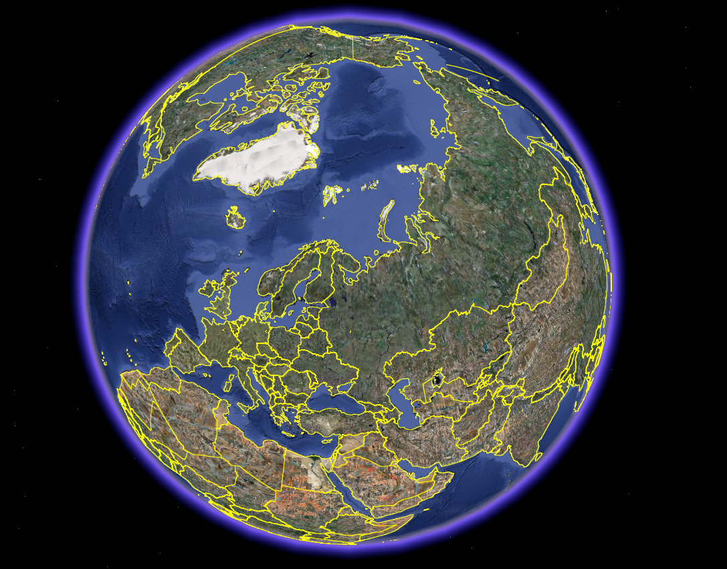

Figure 1.
No country has a larger forest than Russia. The growing stock is 25.5 times larger in Russia than in Sweden and the growing stock is 37.3 times larger in Russia than in Finland. The sustainable long run utilization of the Russian forest could increase very much, maybe ten times! (The harvest levels of the main wood assortments are only 2 – 3 times higher than in Sweden.)
Sources: Compare the main text.

