Ekonomisk optimering av plantage
Peter Lohmander 2010-01-09
http://www.Lohmander.com/Plantage100109.pdf

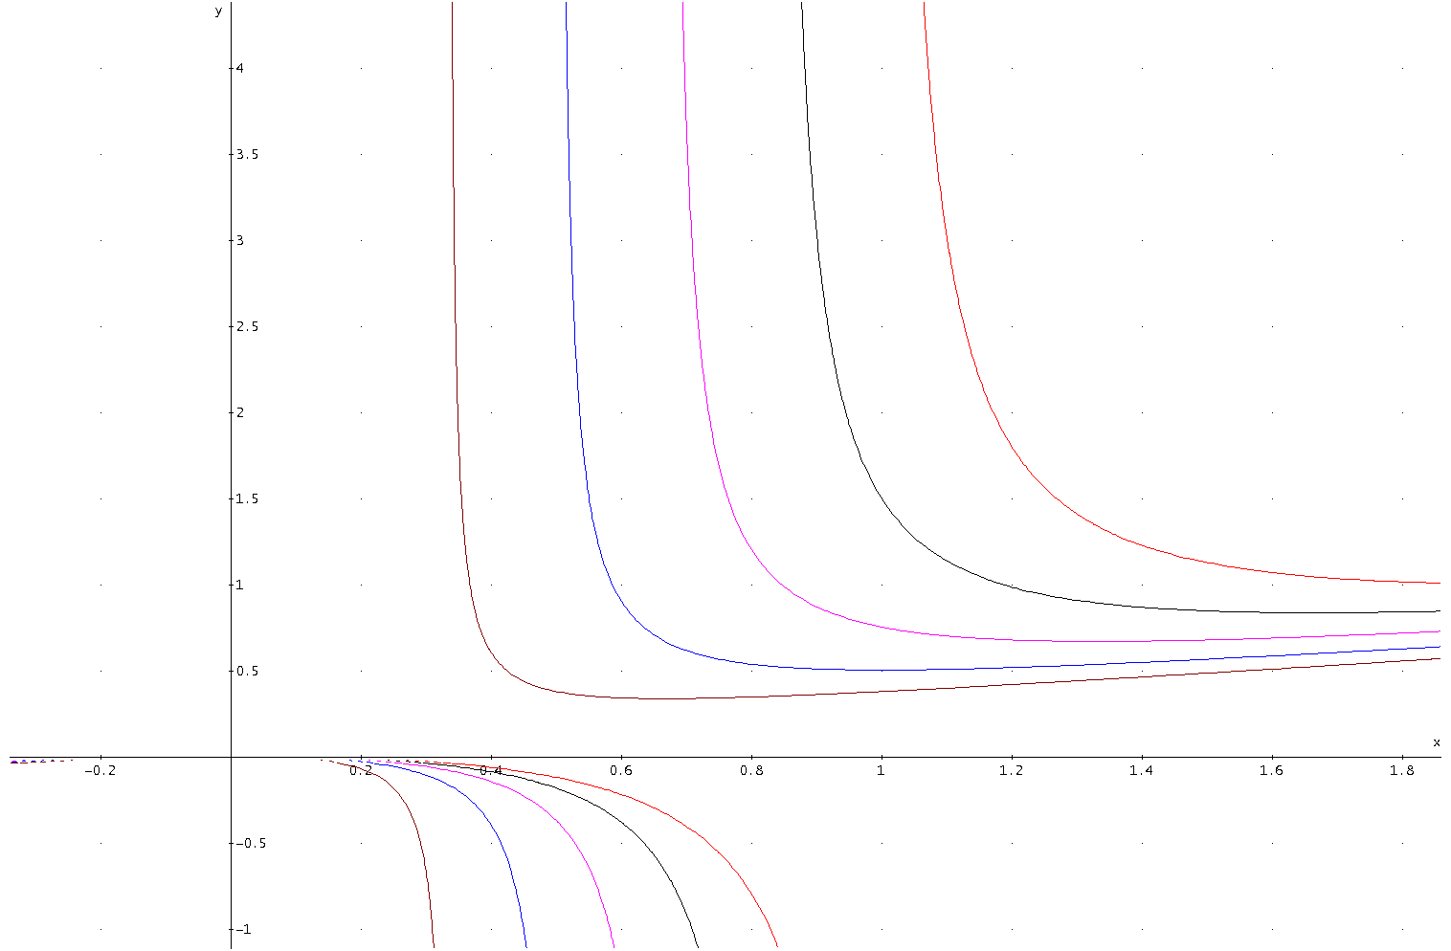
Figur 1.
Isokvanter baserade på funktionen , q = 100, 150, 200, 250, 300

model:
max = nuv;
nuv = p*q - rx*x - ry*y;
q = 300*(x-x^2/(4*y));
q = 100;
p = disk*200;
disk = @exp(-r*t);
r = .03;
t = 80;
rx = 1700;
ry = 1700;
kvot = y/x;
@free(nuv);
end

Global optimal solution found.
Objective value: 330.8065
Objective bound: 330.8067
Infeasibilities: 0.1136868E-12
Extended solver steps: 4
Total solver iterations: 1373

Variable Value Reduced Cost
NUV 330.8065 0.000000
P 18.14359 0.000000
Q 100.0000 0.000000
RX 1700.000 0.000000
X 0.4824045 0.1940475E-07
RY 1700.000 0.000000
Y 0.3902735 0.000000
DISK 0.9071795E-01 0.000000
R 0.3000000E-01 0.000000
T 80.00000 0.000000
KVOT 0.8090170 0.000000

model:
max = nuv;
nuv = p*q - rx*x - ry*y;
q = 300*(x-x^2/(4*y));
q = 200;
p = disk*200;
disk = @exp(-r*t);
r = .03;
t = 80;
rx = 1700;
ry = 1700;
kvot = y/x;
@free(nuv);
end

Global optimal solution found.
Objective value: 661.6129
Objective bound: 661.6134
Infeasibilities: 0.2842171E-13
Extended solver steps: 4
Total solver iterations: 1024

Variable Value Reduced Cost
NUV 661.6129 0.000000
P 18.14359 0.000000
Q 200.0000 0.000000
RX 1700.000 0.000000
X 0.9648091 0.000000
RY 1700.000 0.000000
Y 0.7805469 0.000000
DISK 0.9071795E-01 0.000000
R 0.3000000E-01 0.000000
T 80.00000 0.000000
KVOT 0.8090170 0.000000

model:
max = nuv;
nuv = p*q - rx*x - ry*y;
q = 300*(x-x^2/(4*y));
q = 300;
p = disk*200;
disk = @exp(-r*t);
r = .03;
t = 80;
rx = 1700;
ry = 1700;
kvot = y/x;
@free(nuv);
end

Global optimal solution found.
Objective value: 992.4194
Objective bound: 992.4200
Infeasibilities: 0.000000
Extended solver steps: 4
Total solver iterations: 1617

Variable Value Reduced Cost
NUV 992.4194 0.000000
P 18.14359 0.000000
Q 300.0000 0.000000
RX 1700.000 0.000000
X 1.447214 0.000000
RY 1700.000 0.000000
Y 1.170820 0.000000
DISK 0.9071795E-01 0.000000
R 0.3000000E-01 0.000000
T 80.00000 0.000000
KVOT 0.8090170 0.000000

model:
max = nuv;
nuv = p*q - rx*x - ry*y;
q = 300*(x-x^2/(4*y));
q = 200;
p = disk*200;
disk = @exp(-r*t);
r = .03;
t = 80;
rx = 1700;
ry = 850;
kvot = y/x;
@free(nuv);
end

Global optimal solution found.
Objective value: 1362.051
Objective bound: 1362.052
Infeasibilities: 0.1110223E-15
Extended solver steps: 7
Total solver iterations: 1142

Variable Value Reduced Cost
NUV 1362.051 0.000000
P 18.14359 0.000000
Q 200.0000 0.000000
RX 1700.000 0.000000
X 0.8888889 0.000000
RY 850.0000 0.000000
Y 0.8888889 0.000000
DISK 0.9071795E-01 0.000000
R 0.3000000E-01 0.000000
T 80.00000 0.000000
KVOT 1.000000 0.000000

model:
max = nuv;
nuv = p*q - rx*x - ry*y;
q = 300*(x-x^2/(4*y));
q = 200;
p = disk*200;
disk = @exp(-r*t);
r = .03;
t = 80;
rx = 1700;
ry = 3400;
kvot = y/x;
@free(nuv);
end

Global optimal solution found.
Objective value: -600.9395
Objective bound: -600.9390
Infeasibilities: 0.5684342E-13
Extended solver steps: 4
Total solver iterations: 1693

Variable Value Reduced Cost
NUV -600.9395 0.000000
P 18.14359 0.000000
Q 200.0000 0.000000
RX 1700.000 0.000000
X 1.051567 0.000000
RY 3400.000 0.000000
Y 0.7182335 -0.1232679E-06
DISK 0.9071795E-01 0.000000
R 0.3000000E-01 0.000000
T 80.00000 0.000000
KVOT 0.6830127 0.000000

Referenser:

Referenser som är väldigt starkt kopplade till det aktuella exemplet:

Lohmander, P., The economically optimal number of plants, the damage probability and the stochastic roundwood market, in Paredes, G. (editor), Forest management in acompetitive and environmentally concious world, proceedings from: International Symposium on Systems Analysis and Management Decisions in Forestry, March 9-12,Valdivia, 1993, Chile, 290-314, 1994

Lohmander, P., Plantation, 2004-04-28,
http://www.lohmander.com/program/Plantering/C2.htm

Lohmander, P., Den ekonomiskt optimala skogsplanteringen, 2003-10-10,
http://www.lohmander.com/Kurser/SkogEkIntro/Jagm2.doc

Lohmander, P., Ekonomisk optimering av plantering, 2004-04-28,
http://www.lohmander.com/program/Plantering/InPlant3.html

Referenser som i många fall berör angränsande frågor:

http://www.lohmander.com/Information/Ref.htm

http://www.lohmander.com/Kurser/Kurser.htm

http://www.lohmander.com/Program/Program.htm

