http://www.Lohmander.com/mil/ORFAU1.pdf

Operations Research for Army Units
- Methodology for optimal combat decisions
Peter Lohmander
http://www.lohmander.com/
Version 2010-02-10

CASE 1.
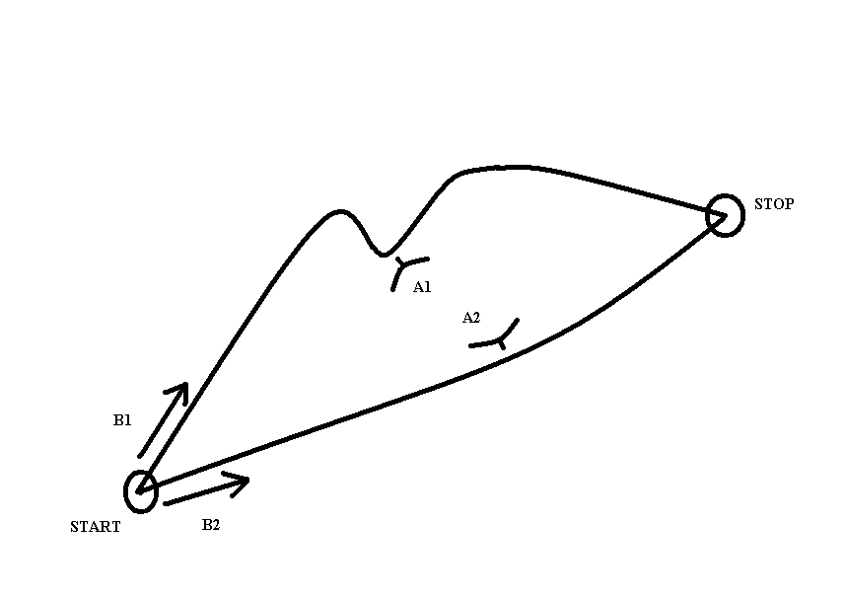

Figure 1.1.

 |  | B1 | B2
 |  | Y1 | Y2
A1 | X1 | C11 | 0
A2 | X2 | 0 | C22

 |  | B1 | B2
 |  | Y1 | Y2
A1 | X1 | 2 | 0
A2 | X2 | 0 | 1

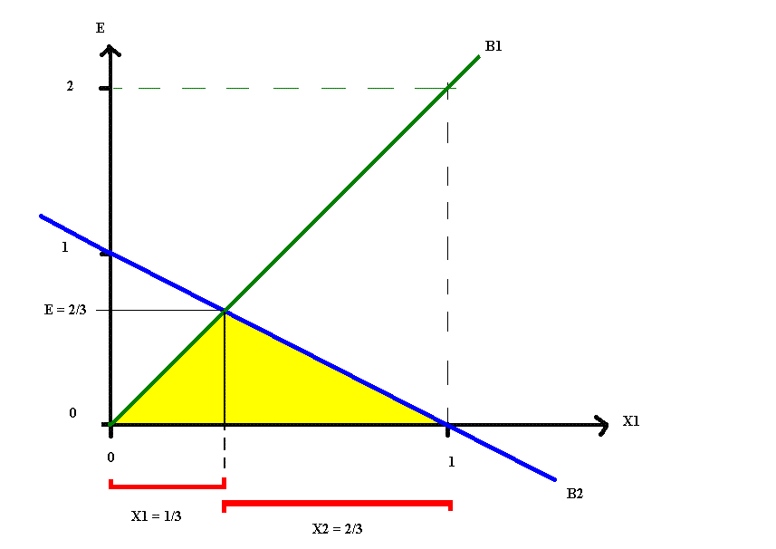

Figure 1.2.

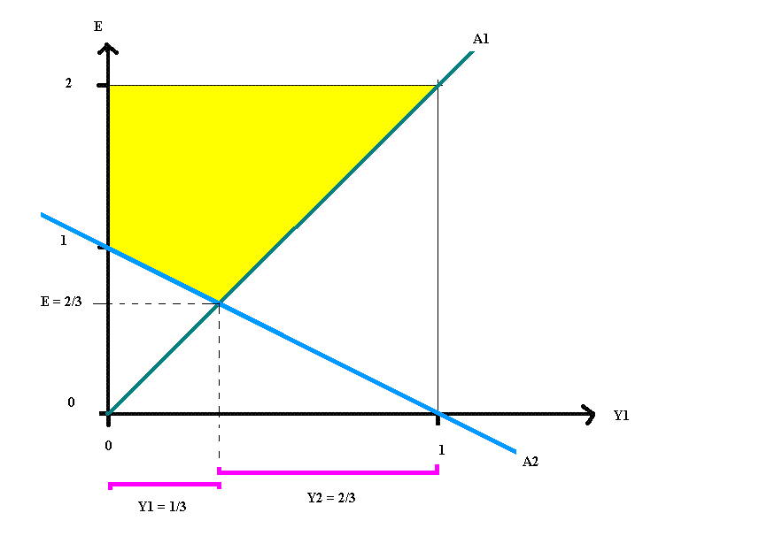

Figure 1.3.

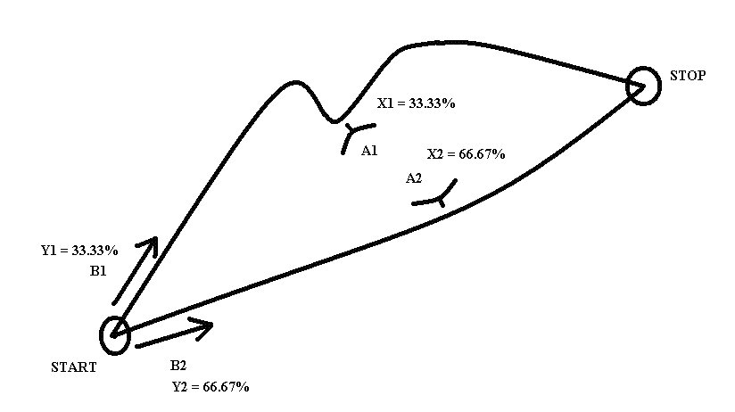
Figure 1.4.

CASE 2.

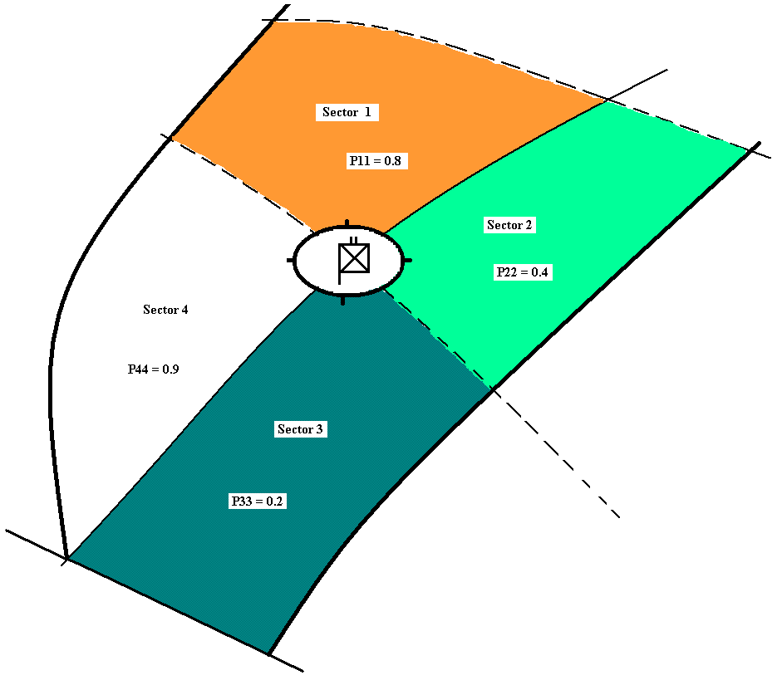

Figure 2.1.

Assumption: All x’s are strictly positive. (The usual case.)

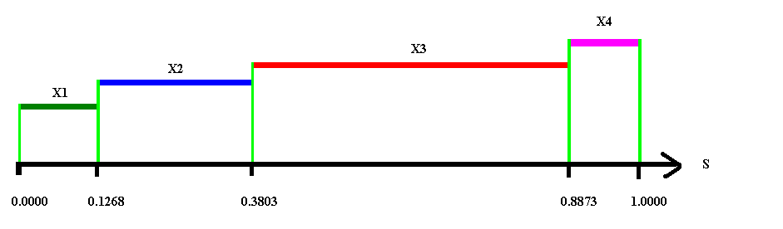

Figure 2.2.

Assumption: All y’s are strictly positive. (The usual case.)

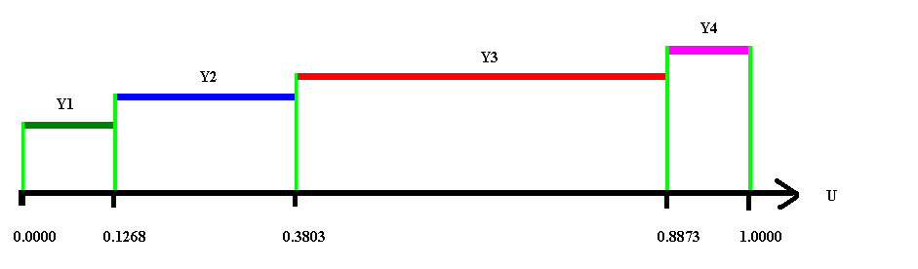

Figure 2.3.

Test:

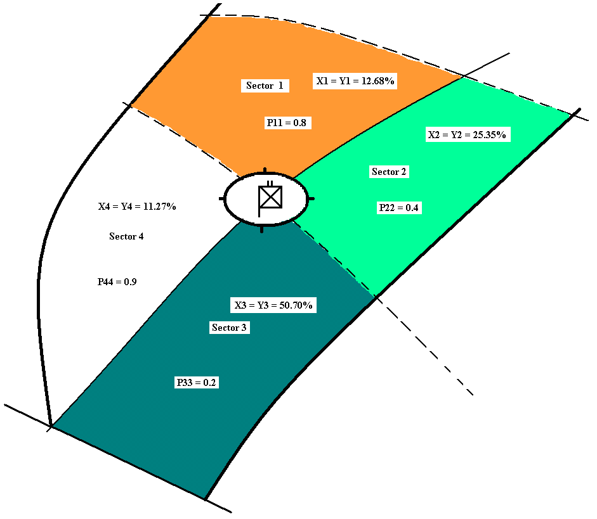

Figure 2.4.

Case 3.

Complete example (in Swedish) with general software:
http://www.lohmander.com/mil/2pzsg/Taktik_PL_1.htm

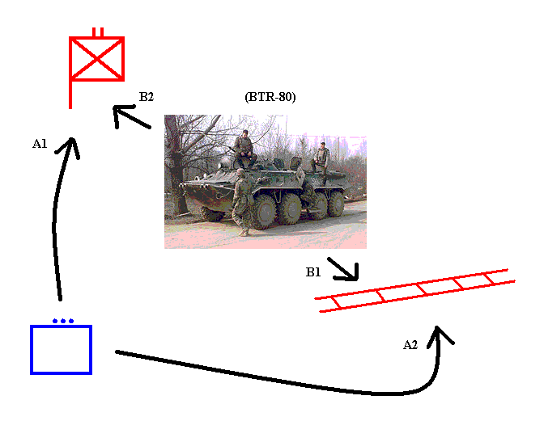

Figure 3.1.

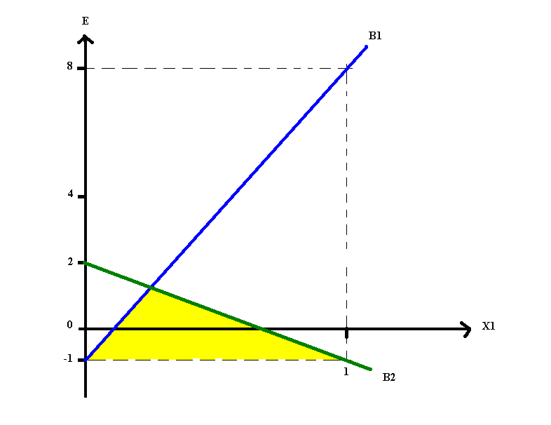

Figure 3.2.

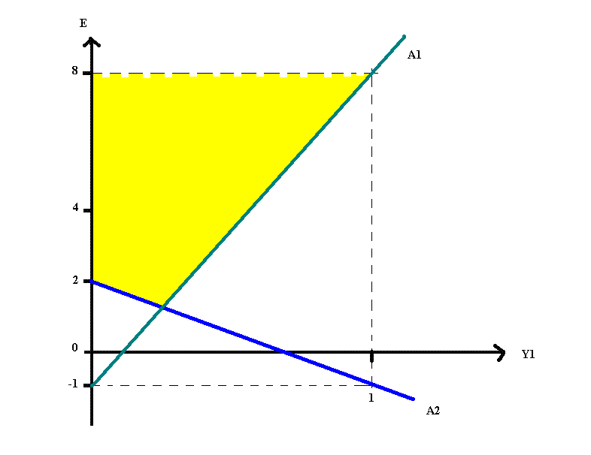

Figure 3.3.

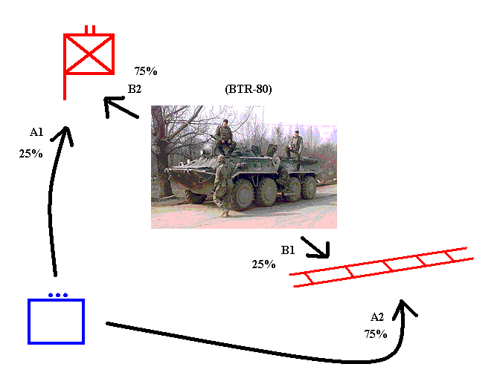

Figure 3.4.

Case 4.

Complete example (in Swedish) with general software:
http://www.lohmander.com/mil/ResFStri.html

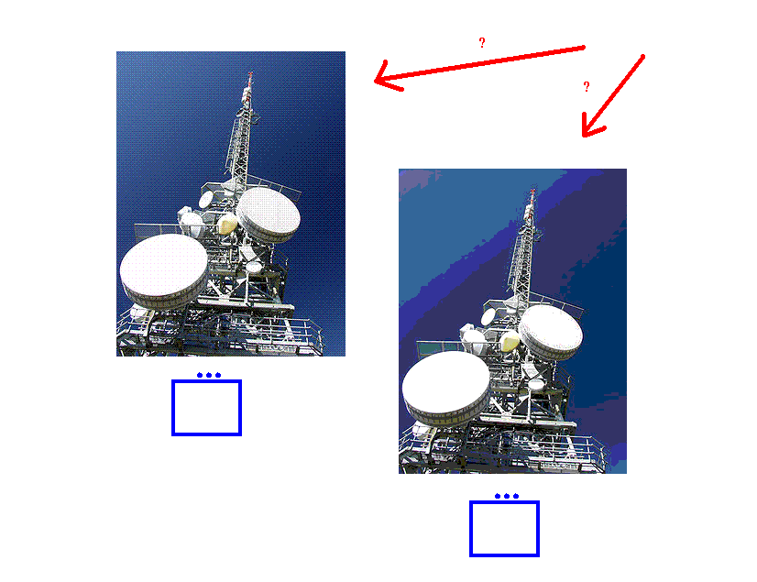

Figure 4.1.

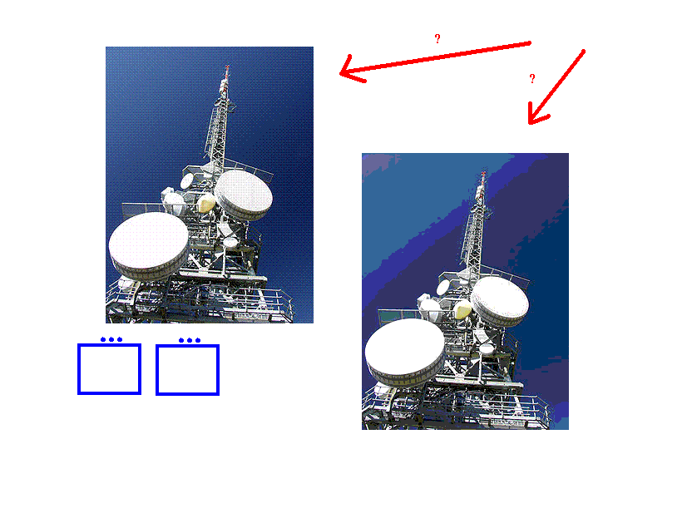
Figure 4.2.

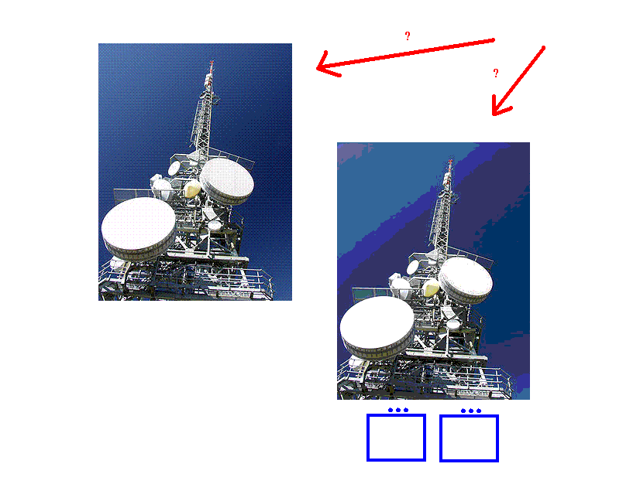
Figure 4.3.

Table 1.
Summary of results reported here:
http://www.lohmander.com/mil/ResFStri.html
(Value of one object)/(Value of one unit) = w | Probability that attack with one unit per object is optimal | Probability that a concentrated attack against only one object is optimal | Probability that the defence should use one unit per object | Probability that a concentrated defence of only one object is optimal
2 | 63% | 37% | 50% | 50%
4 | 45% | 55% | 78% | 22%
10 | 32% | 68% | 97% | 3%

Table 2. (Swedish version of Table 1.)
Sammanfattning av resultat som rapporteras här:
http://www.lohmander.com/mil/ResFStri.html
(Värdet av ett objekt)/(värdet av en grupp) = w | Sannolikhet att A bör anfalla med en grupp mot varje objekt | Sannolikhet att A bör anfalla kraftsamlat med 2 grupper mot ett objekt | Sannolikhet att B bör skydda varje objekt med en grupp per objekt | Sannolikhet att B bör kraftsamla 2 grupper till skydd av ett objekt
2 | 63% | 37% | 50% | 50%
4 | 45% | 55% | 78% | 22%
10 | 32% | 68% | 97% | 3%

