L2b

Special information on result reports and options
Peter Lohmander 090909

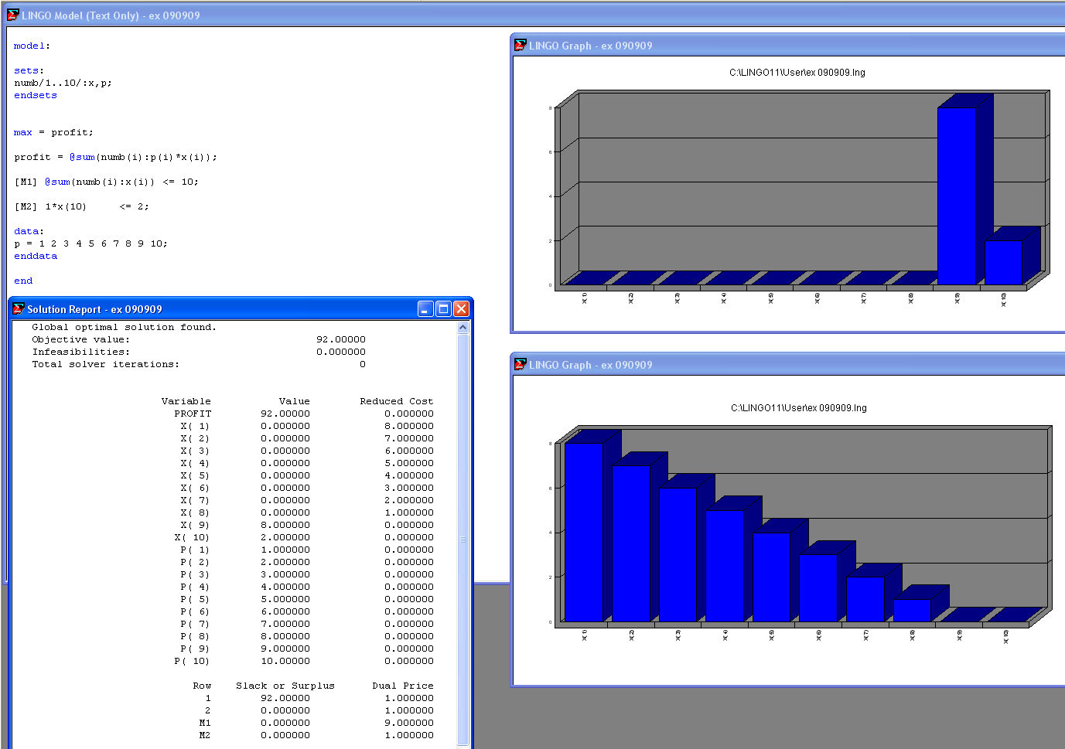

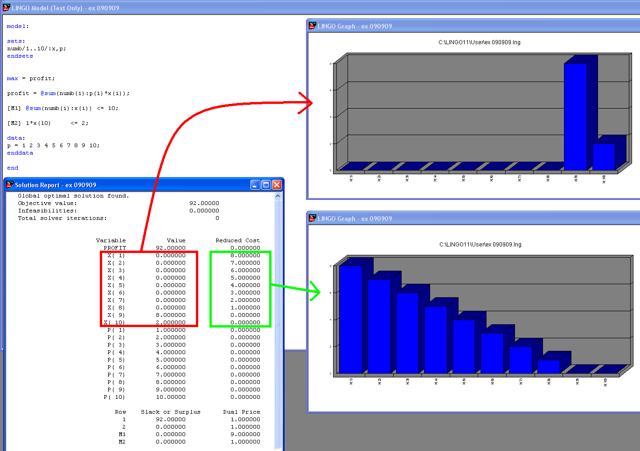

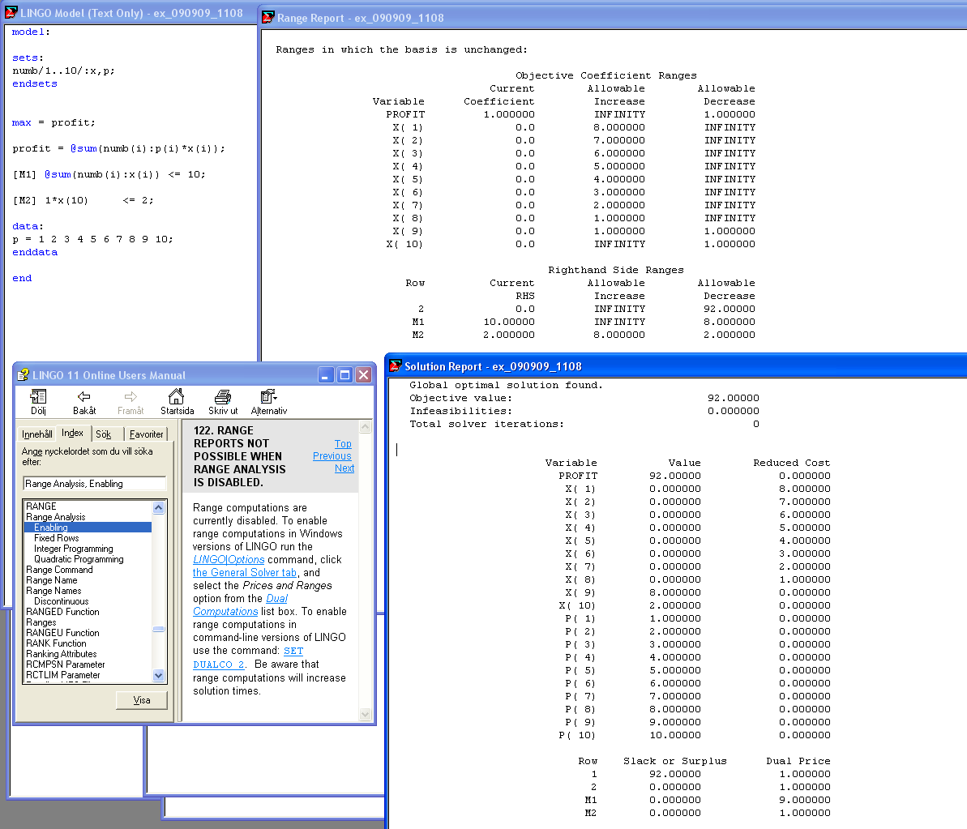

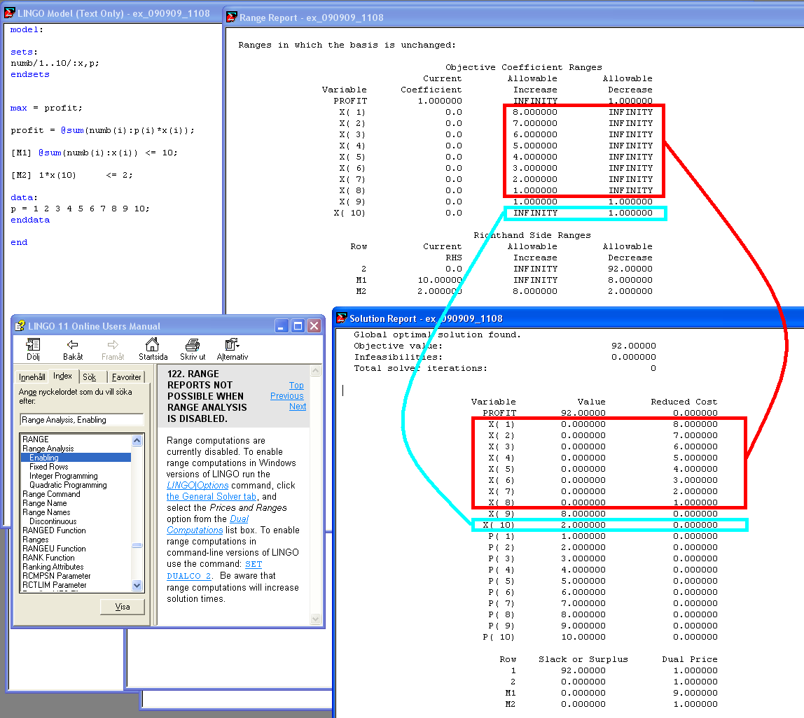

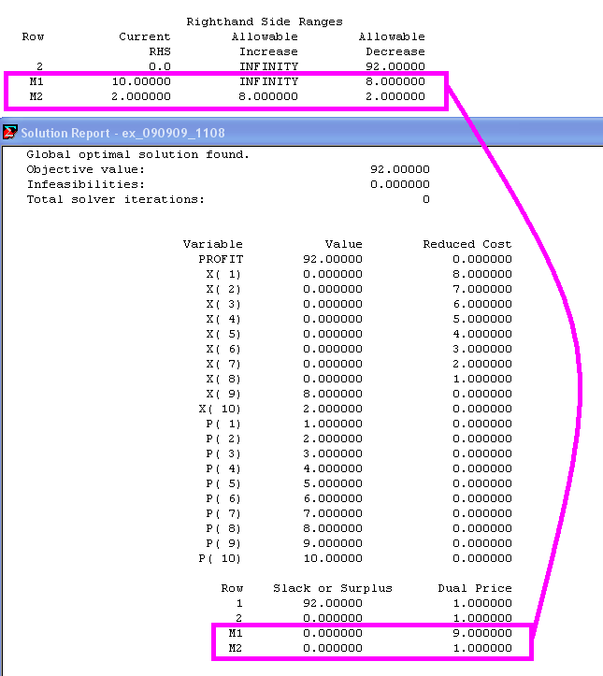

How to calculate and send dual and other information to textfiles and at the same time to input and export data from Excel:

model:

sets:
numb/1..10/:x,p;
z1;
endsets

max = profit;

profit = @sum(numb(i):p(i)*x(i));

[M1] @sum(numb(i):x(i)) <= 10;

[M2] 1*x(10) <= 2;

data:
p = @OLE('ex3.XLS');
@OLE('ex3.XLS')= x;

@TEXT('ex_X.txt') = @WRITE(@NEWLINE(1), "Product Volume", @NEWLINE(2));

@TEXT('ex_X.txt') = @WRITEFOR(numb(i): @FORMAT(i, '5.3g'), @FORMAT(X(i), '10.2g'), @NEWLINE(1));

@TEXT('ex_DUALX.txt') = @WRITE(@NEWLINE(1), "Product DUAL SLACK", @NEWLINE(2));

@TEXT('ex_DUALX.txt') = @WRITEFOR(numb(i): @FORMAT(i, '5.3g'), @FORMAT(@DUAL(x(i)), '12.2g'), @NEWLINE(1));

enddata

end

Global optimal solution found.
Objective value: 140.0000
Infeasibilities: 0.000000
Total solver iterations: 0

Export Summary Report
---------------------
Transfer Method: OLE BASED
Workbook: ex3.XLS
Ranges Specified: 1
X
Ranges Found: 1
Range Size Mismatches: 0
Values Transferred: 10

Variable Value Reduced Cost
PROFIT 140.0000 0.000000
X( 1) 0.000000 13.00000
X( 2) 0.000000 12.00000
X( 3) 0.000000 11.00000
X( 4) 10.00000 0.000000
X( 5) 0.000000 9.000000
X( 6) 0.000000 8.000000
X( 7) 0.000000 7.000000
X( 8) 0.000000 6.000000
X( 9) 0.000000 5.000000
X( 10) 0.000000 4.000000
P( 1) 1.000000 0.000000
P( 2) 2.000000 0.000000
P( 3) 3.000000 0.000000
P( 4) 14.00000 0.000000
P( 5) 5.000000 0.000000
P( 6) 6.000000 0.000000
P( 7) 7.000000 0.000000
P( 8) 8.000000 0.000000
P( 9) 9.000000 0.000000
P( 10) 10.00000 0.000000

Row Slack or Surplus Dual Price
1 140.0000 1.000000
2 0.000000 1.000000
M1 0.000000 14.00000
M2 2.000000 0.000000

