L1 (By Peter Lohmander 2009-08-31)

Ex1:

model:

sets:

resource/1..2/: cap;
product/1..2/: x;
resprod(resource, product):a;
endsets

[eq_1] a(1,1)*x(1) + a(1,2)*x(2) = cap(1);

[eq_2] a(2,1)*x(1) + a(2,2)*x(2) = cap(2);

data:

cap = 10 10;

a = 1 2
2 1;

enddata

end

Feasible solution found.
Infeasibilities: 0.000000
Total solver iterations: 0

Variable Value
CAP( 1) 10.00000
CAP( 2) 10.00000
X( 1) 3.333333
X( 2) 3.333333
A( 1, 1) 1.000000
A( 1, 2) 2.000000
A( 2, 1) 2.000000
A( 2, 2) 1.000000

Row Slack or Surplus
EQ_1 0.000000
EQ_2 0.000000

Ex2:

model:

sets:

resource/1..2/: cap;
product/1..2/: x;
resprod(resource, product):a;
endsets

[eq_1] a(1,1)*x(1) + a(1,2)*x(2) = cap(1);

[eq_2] a(2,1)*x(1) + a(2,2)*x(2) = cap(2);

data:

cap = @OLE('ex2.XLS');

a = 1 2
2 1;

@OLE('ex2.XLS') = x;

enddata

end

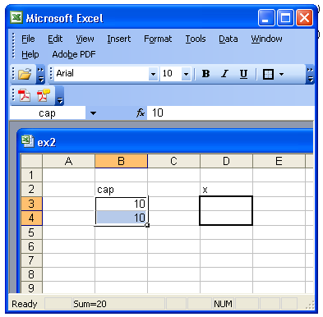

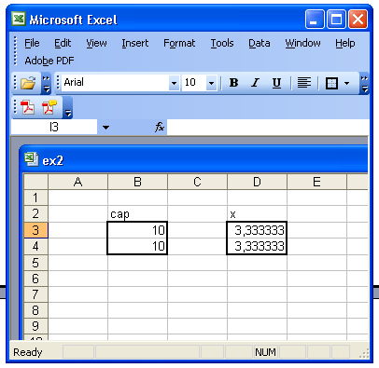

Feasible solution found.
Infeasibilities: 0.000000
Total solver iterations: 0

Export Summary Report
---------------------
Transfer Method: OLE BASED
Workbook: ex2.XLS
Ranges Specified: 1
X
Ranges Found: 1
Range Size Mismatches: 0
Values Transferred: 2

Variable Value
CAP( 1) 10.00000
CAP( 2) 10.00000
X( 1) 3.333333
X( 2) 3.333333
A( 1, 1) 1.000000
A( 1, 2) 2.000000
A( 2, 1) 2.000000
A( 2, 2) 1.000000

Row Slack or Surplus
EQ_1 0.000000
EQ_2 0.000000

Ex3:

model:

sets:

resource/1..2/: cap;
product/1..2/: x;
resprod(resource, product):a;
endsets

[eq_1] a(1,1)*x(1) + a(1,2)*x(2) = cap(1);

[eq_2] a(2,1)*x(1) + a(2,2)*x(2) = cap(2);

data:

cap = 10 1;

a = 1 2
2 1;

enddata

end

No feasible solution found.
Infeasibilities: 4.000000

Ex 4:

model:

sets:

resource/1..2/: cap;
product/1..2/: x;
resprod(resource, product):a;
endsets

[eq_1] a(1,1)*x(1) + a(1,2)*x(2) = cap(1);

[eq_2] a(2,1)*x(1) + a(2,2)*x(2) = cap(2);

@free(x(1));
@free(x(2));

data:

cap = 10 1;

a = 1 2
2 1;

enddata

end

Feasible solution found.
Infeasibilities: 0.000000
Total solver iterations: 0

Variable Value
CAP( 1) 10.00000
CAP( 2) 1.000000
X( 1) -2.666667
X( 2) 6.333333
A( 1, 1) 1.000000
A( 1, 2) 2.000000
A( 2, 1) 2.000000
A( 2, 2) 1.000000

Row Slack or Surplus
EQ_1 0.000000
EQ_2 0.000000

Ex 5:

model:

sets:

resource/1..2/: cap;
product/1..2/: x;
resprod(resource, product):a;
endsets

[eq_1] a(1,1)*x(1) + a(1,2)*x(2) = cap(1);

[eq_2] a(2,1)*x(1) + a(2,2)*x(2) = cap(2);

@FOR( product(j) : @free(x(j)) );

data:

cap = 10 1;

a = 1 2
2 1;

enddata

end

Feasible solution found.
Infeasibilities: 0.000000
Total solver iterations: 0

Variable Value
CAP( 1) 10.00000
CAP( 2) 1.000000
X( 1) -2.666667
X( 2) 6.333333
A( 1, 1) 1.000000
A( 1, 2) 2.000000
A( 2, 1) 2.000000
A( 2, 2) 1.000000

Row Slack or Surplus
EQ_1 0.000000
EQ_2 0.000000

Ex 6:

model:

sets:

resource/1..2/: cap;
product/1..2/: x;
resprod(resource, product):a;
endsets

@for( resource(i) : [equation] @sum( product(j) : a(i,j)*x(j)) = cap(i));

@FOR( product(j) : @free(x(j)) );

data:

cap = 10 1;

a = 1 2
2 1;

enddata

end

Feasible solution found.
Infeasibilities: 0.000000
Total solver iterations: 0

Variable Value
CAP( 1) 10.00000
CAP( 2) 1.000000
X( 1) -2.666667
X( 2) 6.333333
A( 1, 1) 1.000000
A( 1, 2) 2.000000
A( 2, 1) 2.000000
A( 2, 2) 1.000000

Row Slack or Surplus
EQUATION( 1) 0.000000
EQUATION( 2) 0.000000

Ex 7:

sets:

resource/1..2/: cap;
product/1..2/: x;
resprod(resource, product):a;
endsets

@for( resource(i) : [equation] @sum( product(j) : a(i,j)*x(j)) = cap(i));

@FOR( product(j) : @free(x(j)) );

data:

cap = 10 1;

a = 4 2
2 1;

enddata

end

No feasible solution found.
Infeasibilities: 4.000000

Ex 8:

model:

sets:

product/1..2/: x;

endsets

[first] 10*x(1) + 1*x(2) = 14;

[second] x(1)*x(1) = 1.2;

@free(x(1));

end

Feasible solution found.
Infeasibilities: 0.7754610E-09
Extended solver steps: 5
Total solver iterations: 4

Variable Value
X( 1) 1.095445
X( 2) 3.045549

Row Slack or Surplus
FIRST 0.000000
SECOND 0.000000

Ex 9:

model:

sets:

product/1..2/: x;

endsets

[first] 10*x(1) + 1*x(2) = 14;

[second] x(1)*x(1) = 1.2;

@free(x(1));
@free(x(2));

[const_1] x(1) <= 0.5;

end

Feasible solution found.
Infeasibilities: 0.2220446E-15
Extended solver steps: 5
Total solver iterations: 12

Variable Value
X( 1) -1.095445
X( 2) 24.95445

Row Slack or Surplus
FIRST 0.000000
SECOND 0.000000
CONST_1 1.595445

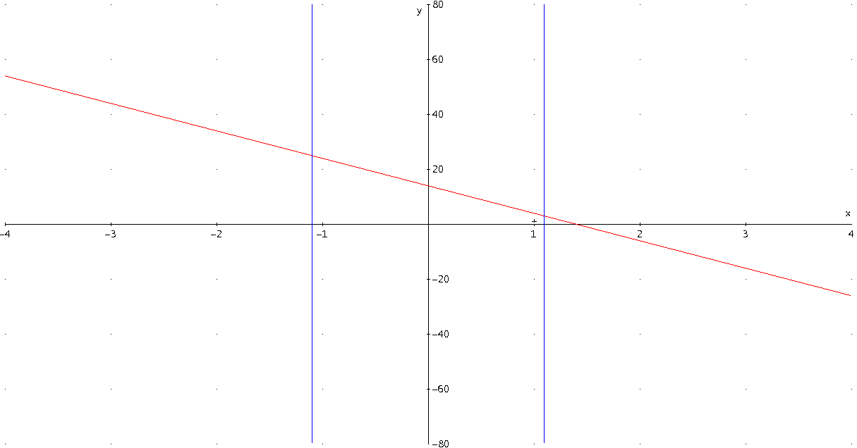

Figure 1.
Illustration to Ex 8. and Ex 9.

